Animation Storyboard
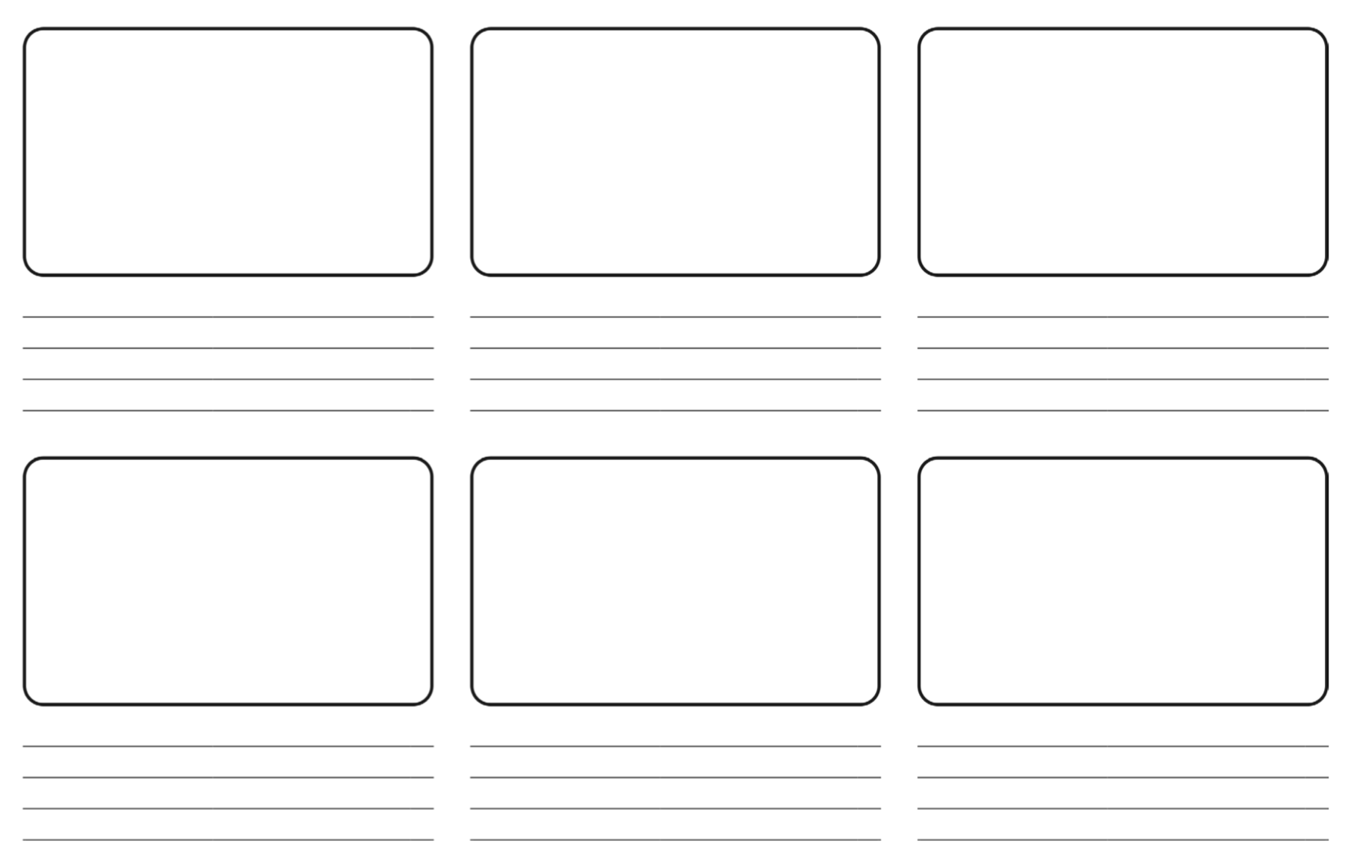
Create a storyboard of your animation. Remember, you will have to create this on 2animate and Scratch, so do not make it too complicated and only have 2 characters.

