Chapter 2

Fourteen years later, an unusual smell of baking filled the kitchen at Pigsticking farm.
“There!” Aggie Onion banged the plate down on the table. “Look at that!”
“Cake!” breathed Yurt. “WOW!”
“WOW!” echoes six of his seven younger brothers.
The cake was small, lumpy and burnt. All the same, it was a cake, and cakes were hardly evert seen at Pigsticking Farm. The wife of a pig farmer for eighteen years, Aggie was limited in her ingredients; sausages, pork pies, ham sandwiches and bacon butties were her usual offerings.
“And it’s got icing!” Kip’s eyes were very wide.
Whelk, Kip’s twin, leant over the table to look. “Icing with writing on!”
Yurt spelt it out. “Good luck Magnifico!”
Mrs Onion wiped her hands on her greasy apron and smiled proudly. “Special day, today,” she said. “Celebrating, that’s what we’re doing! Celebrating our happy hero.”
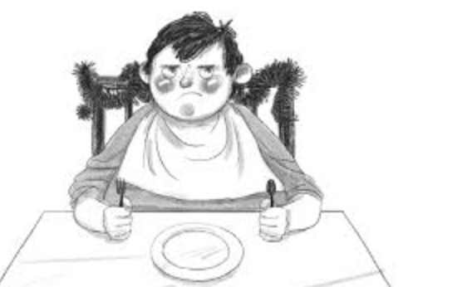
Seven pairs of eyes turned to look. The hero was slumped at the head of the table . under his substantial bottom was a well-worn velvet cushion, and a piece of tarnished tinsel was wound in and out of the chair back. The expression on his face suggested that he was far from happy.

Mrs Onion produced a knife and carefully cut the cake down the middle. “This afternoon,” she announced, “our Magnifico goes adventuring!”
She put half the cake onto the hero’s cake, then divided the other half into six slices.
“What about Alfie, Ma?” Yurt asked.
His mother looked annoyed. “Makes it awkward, seven slices. Alfie doesn’t mind, do you Alf?” she said.
Alfie shook his head. “I don’t mind Ma.”
Under the table Bowser, Alfie’s dog, growled angrily. He’d seen Alfie being left out far too often, and he didn’t think it was right. “Unfair unfair unfairrrrrrrr.” He muttered. Fortunately, Alfie was the only one who understood him. “Ssh!” he warned. “I don’t mind. Not really.”
Once the cake had been eaten, Aggie stomped over to a cupboard and flung open the door, revealing a large paper parcel tied up with string. “Been saving these for years and years,” she said. “And now the time’s come at last. Stand up, Magnifico, and we’ll get you ready.”
Magnifico stared at his mother. “What? What do you mean?”
Aggie beamed fondly at her favourite son. “You’ve got to be dressed right for adventuring. It’s like I said, today’s the day. It’s the seventh day of the seventh month and YOU, Magnifico Onion, are the seventh son of a seventh son.”

I can infer meaning from a text.

- Aggie beamed fondly at her favourite son. Tick two words that are similar to fondly.

Warmly
Passionately
Disdainfully
Disapprovingly

- Look at the paragraph beginning: Seven pairs of eyes turned to look... which ends: ...suggested that he was far from happy. (Page 11)
What impressions of Magnifico do you get from this? Give two.

1.

2.

- Do you think Alfie Onion is treated unfairly in the beginning of the text?

Tick one

Yes

No

Maybe

Explain your choice fully, using evidence from the text.

