This half term in Year 2 we will be learning...
Literacy
We will continue to follow the National Curriculum and follow a Literature Works approach to learning; we will explore engaging and challenging topic related texts and different writing genres through poetry and non-fiction texts. In reading we will focus on the use of inference skills. In writing we will consolidate spelling, punctuation and grammar skills taught so far this year. We will also improve our proof reading skills.

Art and DT
Children will explore how to use a range of materials to explore self-portraiture, through drawing, collage and sculpture.
In DT, children design, make and evaluate photograph frames for a special photo.

Numeracy
This half term we will revisit addition and subtraction methods but will have a focus on times tables and using multiplication and division. We will also revisit 2D and 3D shape, statistics and measurement including time and money.

History/Geography
In History we will look at the children’s personal history so far. In Geography, the children will have the opportunity to share photographs and memories of special places they have visited.

ICT
The children will learn to use technology purposefully to organise, store, manipulate digital content.

Happy, Healthy Me!
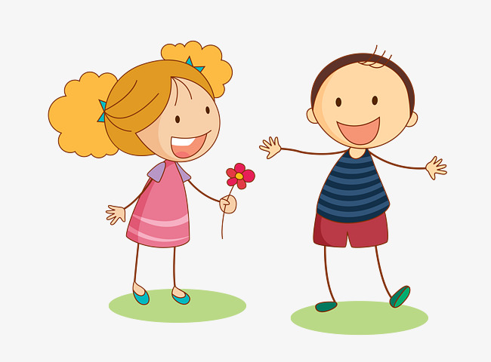

R.E and PSHCE
In R.E. the children will begin to learn about Islam. We will find out about the key beliefs and differences between Islam and Christianity,

In PSHCE, we will be thinking about our achievements so far, the goals we have and the steps we can take to achieve them.
P.E
In PE we will develop different multi-skills. We have a sports and health themed week to look forward to this month (week beginning 18/06/2018) where we will have the opportunity to try out a range of sports.

Science
In Science we will be learning about the importance for humans of exercise, eating the right amounts of different types of food, and hygiene.
We will continue learning about plants and how they can help us to stay healthy.
Music
In music we will continue to work with a music specialist to learn about scales and notation. We will also develop our repertoire of songs.

