Northumberland
County Council
HEDDON-ON-THE-WALL ST. ANDREW’S CHURCH OF ENGLAND FIRST SCHOOL

Trajan Walk • Heddon-on-the Wall • Northumberland • NE15 0BJ
Telephone 01661 853350
www.heddon-school.co.uk twitter @HeddonSchool
Mr A Wheatley: Headteacher
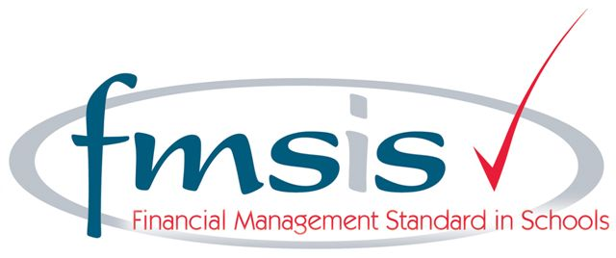

Dear Parents,
For the Parents of Children in Years 2, 3, 4 and 5 in September
Music Lessons
Chris Reay, Music Teacher, will once again teach keyboard and guitar lessons in September. The lessons will take place during the school day and the cost of them must be met by parents for all those children who are not in receipt of free school meals or pupil premium. There will be ten lessons each term and the approximate cost per term is £50 though this depends on the number of children who are having lessons and the length of the term.

If your child currently has lessons, they will continue to have them next term, unless we hear from you, in writing, to the contrary.

If your child will be in Year 2, 3, 4 or 5 in September and would like to begin to learn to play the keyboard, or if your child will be in Year 3, 4 or 5 in September and would like to begin guitar lessons, please fill in the attached slip and return it to school.

Thank you.
Yours sincerely,

Mr A Wheatley,
Headteacher.
………………………………………………………………………………………………………………………………………………….

NAME OF CHILD………………………………………………………………………………………….
CLASS (IN SEPTEMBER)……………………………………………………………………………

My child would like to begin Keyboard/guitar lessons in September.

Signed…………………………………………………………………………………………….(Parent)

