HEDDON-ON-THE-WALL ST. ANDREW’S CE FIRST SCHOOL

Tackling Extremism & Radicalisation Policy
2015-2016

This policy should be read with the following policies:

- Safeguarding & Child Protection Policy;
- Equality Policy;
- Anti-Bullying Policy;
- Positive Behaviour Management Policy;
- E-Safety Policy;
- PREVENT Strategy, HM Government (2011);
- Keeping Children Safe in Education, DfE (DFE-00129-2015, July 2015);
- Working Together to Safeguard Children, HM Government (DFE-00130-2015, March 2015)

Agreed by: | Governing Body
Review date: | October 2015
Previous review date: | N/A New Policy

- POLICY STATEMENT
Heddon-on-the-Wall St. Andrew’s CE First School is fully committed to safeguarding and promoting the welfare of all its pupils. Every member of staff recognises that safeguarding against radicalisation and extremism is no different to safeguarding against any other vulnerability in today’s society. The Tackling Extremism and Radicalisation Policy sets out our beliefs, strategies and procedures to protect vulnerable individuals from being radicalised or exposed to extremist views, by identifying who they are and promptly providing them with support.

2. LINKS TO OTHER POLICIES

The Heddon-on-the-Wall St. Andrew’s CE First School Tackling Extremism and Radicalisation Policy links to the following school policies:

- Child Protection and Safeguarding;
- Equality Policy;
- Anti-bullying Policy;
- Positive Behaviour Management Policy;
- E-Safety Policy.

The following national guidelines should also be read when working with this policy:

- PREVENT Strategy, HM Government (2011);
- Keeping Children Safe in Education, DfE (DFE-00129-2015, July 2015);
- Working Together to Safeguard Children, HM Government (DFE-00130-2015, March 2015)

3. AIMS AND PRINCIPLES

3.1 The Heddon-on-the-Wall St. Andrew’s CE First School Tackling Extremism and Radicalisation Policy is intended to provide a framework for dealing with issues relating to vulnerability, radicalisation and exposure to extreme views. We recognise that we are well placed to be able to identify safeguarding issues and this policy clearly sets out how the school will deal with such incidents and identifies how the curriculum and ethos underpins our actions.

3.2 The objectives are that:

- All Governors, teachers, teaching assistants and non-teaching staff will have an understanding of what radicalisation and extremism are is and why we need to be vigilant in school;
- All Governors, teachers, teaching assistants and non-teaching staff will know what the school policy is on tackling extremism and radicalisation and will follow the policy guidance swiftly when issues arise;
- All learners will understand the dangers of radicalisation and exposure to extremist views; building resilience against these and knowing what to do if they experience them;
- All parents/carers and learners will know that the school has policies in place to keep learners safe from harm and that the school regularly reviews its systems to ensure they are appropriate and effective.

3.3 The main aims of this policy are to ensure that staff are fully engaged in being vigilant about radicalisation; that they overcome professional disbelief that such issues will not happen here and ensure that we work alongside other professional bodies and agencies to ensure that our learners are safe from harm.

4. DEFINTIONS AND INDICATORS

4.1 Radicalisation is defined as the act or process of making a person more radical or favouring of extreme or fundamental changes in political, economic or social conditions, institutions or habits of the mind.

4.2 Extremism is defined as the holding of extreme political or religious views.

4.3 There are a number of behaviours which may indicate a child is at risk of being radicalised or exposed to extreme views. These include:

- Spending increasing time in the company of other suspected extremists;
- Changing their style of dress or personal appearance to accord with the group;
- Day-to-day behaviour becoming increasingly centred on an extremist ideology, group or cause;
- Loss of interest in other friends and activities not associated with the extremist ideology, group or cause;
- Possession of materials or symbols associated with an extremist cause;
- Attempts to recruit others to the group / cause;
- Communications with others that suggests identification with a group, cause or ideology;
- Using insulting to derogatory names for another group;
- Increase in prejudice-related incidents committed by that person – these may include:

* physical or verbal assault;
* provocative behaviour;
* damage to property;
* derogatory name calling;
* possession of prejudice-related materials;
* prejudice related ridicule or name calling;
* inappropriate forms of address;
* refusal to co-operate;
* attempts to recruit to prejudice-related organisations;
* condoning or supporting violence towards others.

5. PROCEDURES FOR REFERRALS

5.1 Although serious incidents involving radicalisation have not occurred at Heddon-on-the-Wall St. Andrew’s CE First School to date, it is important for us to be constantly vigilant and remain fully informed about the issues which affect the local area, city and society in which we teach. Staff are reminded to suspend any ‘professional disbelief’ that instances of radicalisation ‘could not happen here’ and to be ‘professionally inquisitive’ where concerns arise, referring any concerns through the appropriate channels. (See Appendix 1 – Dealing with referrals)

5.2 We believe that it is possible to intervene to protect people who are vulnerable. Early intervention is vital and staff must be aware of the established processes for front line professionals to refer concerns about individuals and / or groups. We must have the confidence to challenge, the confidence to intervene and ensure that we have strong safeguarding practices based on the most up-to-date guidance and best practise.

5.3 Members of the Strategic Leadership Team (SLT) are trained as Designated Senior Leaders for Child Protection and Safeguarding and will deal swiftly with any referrals made by staff or with concerns reported by staff.

5.4 The Headteacher and SLT will discuss the most appropriate course of action on a case-by-case basis and will decide when a referral to external agencies is needed (see Appendix 1 – Dealing with referrals)

5.5 As with any Child Protection referral, staff must be made aware that if they do not agree with a decision not to refer, they can make the referral themselves and will be given the contact details to do this via the safeguarding board in the staffroom.

6. GOVERNORS, LEADERS AND STAFF

6.1 The Headteacher and all members of the SLT are the leaders for referrals relating to extremism and radicalisation. In the unlikely event that no SLT members and the Headteacher are not available, all staff know the channels by which to make referrals via the safeguarding board in the staffroom.

6.2 Staff will be fully briefed about what to do if they are concerned about the possibility of radicalisation relating to a learner, or if they need to discuss specific learners whom they consider to be vulnerable to radicalisation or extremist views.

6.3 The SLT will work in conjunction with the Headteacher, Pastoral Care Team and external agencies to decide the best course of action to address concerns which arise.

6.4 Prejudicial behaviour can be a factor in radicalisation and extremism. With this in mind, Heddon-on-the-Wall St. Andrew’s CE First School has updated procedures for dealing with prejudicial behaviour, as outlined in the Positive Behaviour Policy and Equality Policy.

7. THE ROLE OF THE CURRICULUM

7.1 Our curriculum is “broad and balanced”. It promotes respect, tolerance and diversity. Learners are encouraged to share their views and recognise that they are entitled to have their own different beliefs which should not be used to influence others.

7.2 Our PSHE provision is embedded across the curriculum. It directs our Collective Worship and assemblies and underpins the Christian ethos of the school. It is recognised that learners with low aspirations are more vulnerable to radicalisation and therefore we strive to equip our pupils with confidence, self-belief, respect and tolerance as well as setting high standards and expectations for themselves. (See Appendix 4 – PSHE Curriculum Overview)

7.3 Learners are regularly taught about how to stay safe when using the internet and are encouraged to recognise that people are not always who they say they are online. They are taught to seek adult help if they are upset or concerned about anything they read or see on the internet.

8. STAFF TRAINING

8.1 Through INSET opportunities in school, we will ensure that our staff are fully aware of the threats, risks and vulnerabilities that are linked to radicalisation; are aware of the process of radicalisation and how this might be identified early on and are aware of how we can provide support as a school to ensure that our children are resilient and able to resist involvement in radical or extreme activities. (See Appendix 2- Staff training)

9. VISITORS AND THE USE OF SCHOOL PREMISES

9.1 If any member of staff wishes to invite a visitor in the school, they must first complete a visitor request form. (See Appendix 5 – School Visitor Request Form). Only after written agreement from the Head Teacher can the visitor enter school and then they will be subject to Safeguarding Checks including DBS checks and photo identification. Children are NEVER left unsupervised with external visitors, regardless of safeguarding check outcomes.

9.2 Upon arriving at the school, all visitors including contractors, will read the child protection and safeguarding guidance and be made aware of who the DSLs are and how to report any concerns which they may experience.

9.3 If any agreement is made to allow non-school groups or organisations to use the premises, appropriate checks will be made before agreeing the contract. Usage will be monitored and in the event of any behaviour not in-keeping with the Tackling Extremism and Radicalisation Policy, the school will contact the police and terminate the contract.

10. ADDITIONAL MATERIALS

10.1 See Appendix 3 for further reading

11. POLICY REVIEW

11.1 The Heddon-on-the-Wall St. Andrew’s CE First School Tackling Extremism and Radicalisation Policy will be reviewed annually as part of the overall Child Protection and Safeguarding policy review.

This policy will be ratified by the Governing Body in September 2015

Signed Mrs. M. Stromsoy Chair of Govenors Date: 7th October 2015

This policy will be reviewed on or before the following date: September 2016
Appendix 1 – Dealing with referrals

We are aware of the potential indicating factors that a learner is vulnerable to being radicalised or exposed to extreme views, including peer pressure, influence from other people or the internet, bullying, crime and anti-social behaviour, family tensions, race / hate crime, lack of self-esteem or identity, prejudicial behaviour and personal or political grievances.

In the event of prejudicial behaviour the following system will be followed:

- All incidents of prejudicial behaviour will be reported directly to the SLT or the Head Teacher;
- All incidents will be fully investigated and recorded in line with the Positive Behaviour Policy and records will be kept in line with procedures for any other safeguarding incident;
- Parents / carers will be contacted and the incident discussed in detail, aiming to identify motivating factors, any changes in circumstances at home, parental views of the incident and to assess whether the incident is serious enough to warrant a further referral. A note of this meeting is kept alongside the initial referral in the Safeguarding folder;
- The SLT follow-up any referrals for a period of four weeks after the incident to assess whether there is a change in behaviour and / or attitude. A further meeting with parents would be held if there is not a significant positive change in behaviour;
- If deemed necessary, serious incidents will be discussed and referred to the local children’s social care team;
- In the event of a referral relating to serious concerns about potential radicalisation or extremism, the school will also contact preventmailbox@northumbria.pnn.police.uk

Appendix 2 - Staff Safeguarding Training

Type of Training | Delivered by | Delivered to | When and at what frequency
WRAP (Workshop to Raise Awareness of Prevent) | Mrs. G. Finch  (NCC) | All staff, governors, office staff, site management and dinner supervisors | Repeated for all staff during first half of Autumn half term each academic year
PVE (Preventing Violent Extremism) Training for Managers |  | All SLT, all leadership team, governors with responsibilities for safeguarding | Repeated for all identified staff during first half of Autumn half term each academic year
Safer Recruitment Training |  | All SLT and all governors | Refreshed on 3 year basis. Certificates held in school Safeguarding Folder
Safeguarding and Child Protection Training | Mrs. A. Lambert (NCC) | All SLT and designated governors for child protection | Refreshed on 2 year basis. Certificates held in school Safeguarding Folder
Safeguarding and Child Protection Training – (Dissemination) | Mrs. A. Lambert (NCC) | All staff, governors, office staff, site management and dinner supervisors | Repeated for all staff during first half of Autumn half term each academic year and ongoing in weekly year group and INSET meeting
Tackling Homophobia in Schools |  | All staff, governors, office staff, site management and dinner supervisors | Repeated for all staff during first half of Autumn half term each academic year
Tackling Domestic Violence |  | All staff, office staff, site management and dinner supervisors | Repeated for all staff during first half of Autumn half term each academic year
Tackling Female Genital Mutilation |  | All staff, office staff, site management and dinner supervisors | Repeated for all staff during first half of Autumn half term each academic year
Looked After Children | Mrs. A. Lambert (NCC) | DSL for Looked | Refreshed on 2 year basis.

Appendix 3 - Additional materials (Available in Staffroom, on school website or by searching online)

- PREVENT Strategy, HM Government (2011)
https://www.gov.uk/government/publications/prevent-strategy-2011

- Keeping Children Safe in Education, DfE (DFE-00129-2015, July 2015)
https://www.gov.uk/government/uploads/system/uploads/attachment_data/file/447595/KCSIE_July_2015.pdf

- Working Together to Safeguard Children, HM Government (DFE-00130-2015, March 2015)
https://www.gov.uk/government/publications/working-together-to-safeguard-children--2

- Learning Together to be Safe: a Toolkit to Help Schools Contribute to the Prevention of Violent Extremism was published in 2008 by the Department for Children, Schools and Families (DCSF), a predecessor of the Department for Education.
https://www.education.gov.uk/consultations/downloadableDocs/17132_DIUS_Learning_Be_Safe.pdf

Appendix 4 – PSHE Curriculum Overview – See website: www.heddon-school.co.uk

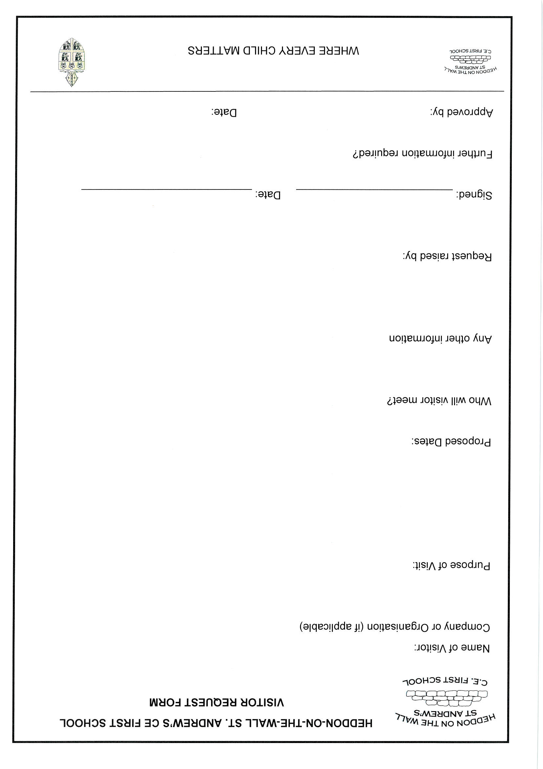
VISITOR INFORMATION
This school is committed to the safety and well-being of all pupils, staff and visitors, therefore all visitors must sign consent to following the following rules before access to the site is granted.

GENERAL | - Enter and exit the site from the main entrance, observe signing in and out procedures;  - Do not move around the school unescorted. Please stay within the areas designated for your visit;  - Please do not interact with pupils unless instructed by a member of staff to do so;  - You will be issued with a visitors pass. This pass must be worn at all times so that it is visible. Please return this to the school office as you sign out and leave;  - Please note that inappropriate behaviour or language on site will not be tolerated, in relation to pupils, staff or visitors;  - Accessible toilets are located next to the staffroom, please do not use any other toilets during your visit.
FIRE | - Please take time to locate your nearest fire exit;  - If the alarm sounds please leave by the nearest exit. Make your way to the assembly point on the field by the main gate so you can be accounted for;  - If you are working with pupils lead them to safety and inform a member of staff so that registers can be taken.
MOBILE PHONES / CAMERAS ETC | When on site:  - Do not use your mobile telephone in areas where pupils are present;  - Do not take images of pupils;  - Do not leave equipment unattended;  - Ensure that the Bluetooth capability of your mobile phone is disabled;  - Do not elicit contact with pupils through social media during or after the visit.
INTERACTION WITH PUPILS | Where your role requires that you interact with pupils or are attending school on Local Authority / Partnership work you must:  - Present your photo ID (and any other agreed documentation between the school / Local Authority or Partnership group;  - Wear your photo ID and Visitors Pass at all times on the school site;  - Interact with pupils as required within your professional capacity and report any instances / concerns / observations you may have immediately to a Senior Member of Staff (Office staff can advise who to contact if appropriate)
CONTENT | When speaking to pupil the following items of content (as set out in the Prevent Strategy) are deemed inappropriate to share with children and therefore may not be discussed or shared:  - Religious extremism, far right views, extremist animal rights or any other extremist views (this includes both violent and non-violent extremism);  - Racist, homophobic or any other views which can be considered discriminatory;  - Promotion of extremist / terrorist / violent ideology or lifestyle or any form of political indoctrination;  - Promotion of symbols or materials related to extremist organisations;  - Any views which promote extremism or radicalisation.

Anyone whose actions or behaviour causes concern or who do not follow the above requirements will be reported to the Local Authority for further action to be taken and may be asked to leave the site.
Please sign below when you have read all of the above criteria.

Signed ……………………………………………… Print Name: ………………………………………

