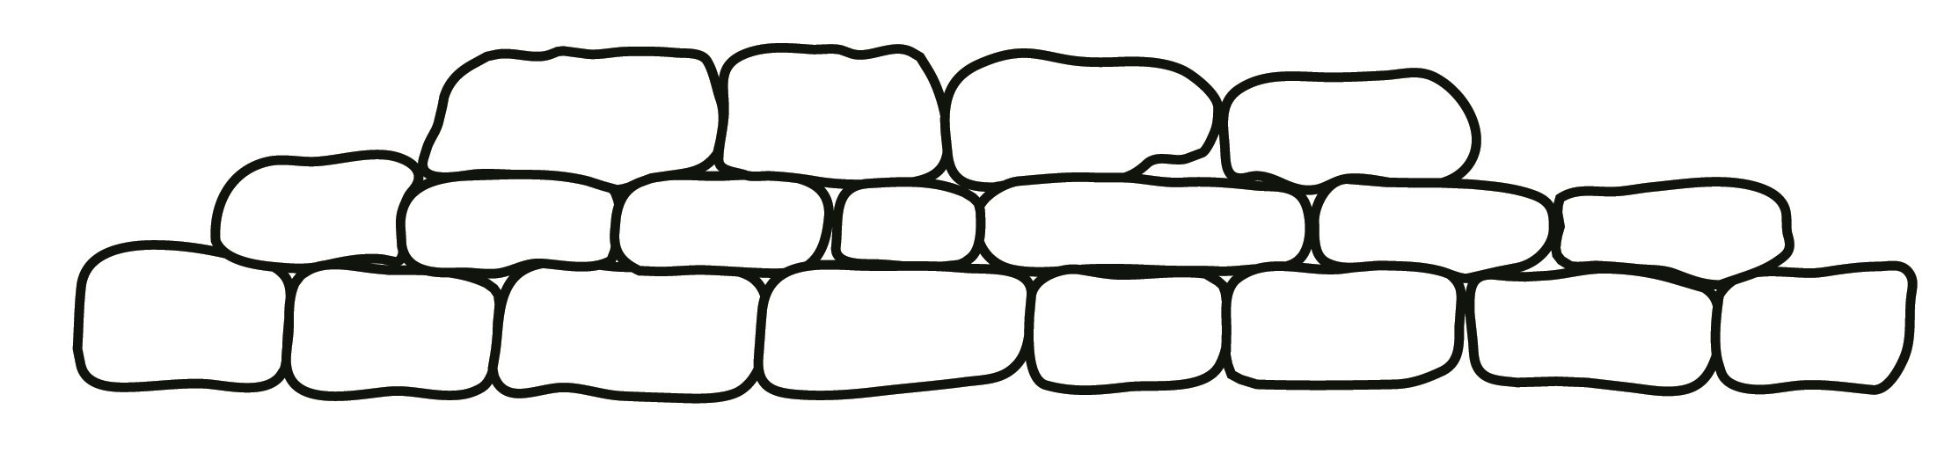

**Early Years Unit**

**Curriculum Leaflet**

**Autumn Term 1 2017**

**People Who**

**Help Us**

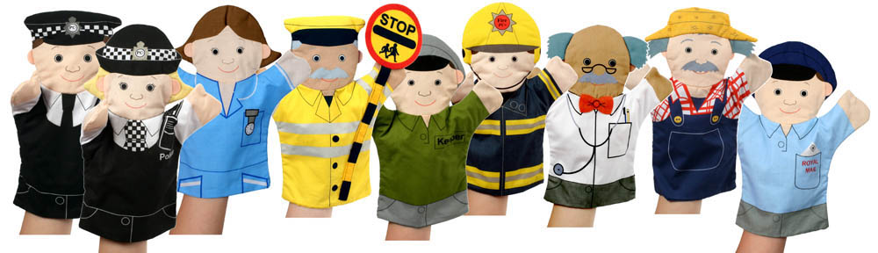

**Nursery – Mrs Leja, Miss Kerridge and Mrs Derbyshire**

**Reception – Mrs Southern, Mrs Abbott and Mrs Haddock**

To start our new academic year in Early Years our topic will be ‘People Who Help Us’. During this topic we will be focussing on people who help us at school as well as in the wider community. We will look at how we can keep ourselves safe and what to do in an emergency.



The aim of this leaflet is to give you an overview of the skills

to be covered during the study of this topic. Due to the child focussed

curriculum in the Foundation Stage, we are unable to specify exactly

what we will be doing as it can change regularly depending on the interests

and abilities of the children.

The children can choose throughout the Early Years Unit as well as outside.

The topic will be used as a vehicle to explore children’s interests within

the seven areas of the Early Years Foundation Stage.

Three Prime Areas: Personal, Social and Emotional Development; Communication and Language; Physical Development.

Four Specific Areas: Literacy; Mathematics; Understanding of the World; Expressive Arts and Design.

Within these areas the children will be learning skills and working towards specific goals. The goals which they will be working towards achieving by the end of the Foundation stage include:

**Personal, Social and Emotional Development**

The topic of People Who Help us offers many opportunities for children’s

personal and social development. By playing circle games children will learn to take turns and to understand the need for agreed codes of behaviour. Throughout the topic there will be an emphasis on safety and we will be looking at fire and road safety as well as stranger danger. There will be a number of role-play opportunities both inside and outside to allow children to use their imaginations and to use speaking and listening within their play.

Children will learn to;

* Continue to be interested, excited and motivated to learn
* Be confident to try activities, initiate ideas and speak in a familiar group
* Maintain attention, concentrate and sit quietly when appropriate
* Have a developing awareness of their own needs, views and feelings of others
* Form good relationships with peers and adults
* Work as part of a group or class, taking turns and sharing fairly
* Dress and undress independently and manage their own personal hygiene
* Select and use activities and resources independently

**Communication and language**

Time will be spent discussing the way people help others and considering the different jobs that people do. This will encourage children to speak in a group, to be interested and to consider consequences.

Children will learn to;

* Give their attention to what others say and respond appropriately, while engaged in another activity.
* Listen to stories, accurately anticipating key events and respond to what they hear
* follow instructions involving several ideas or actions
* express themselves effectively, showing awareness of listeners’ needs

**Literacy**

Using books children will show interest in illustrations and print and look at print in the environment. Through handling books carefully, they will hold books the correct way up and turn the pages. Children will find outhow information can be found in non-fiction texts to answer questions about where, who, why and how. They will write (mark-make) for different purposes including labels for their pictures or models. Throughout the topic children will be encouraged to explore sounds of words, use descriptive vocabulary and see some of their ideas displayed in pictures and words.

Children will learn to;

* Explore and experiment with sounds, words and text
* Hear and say the initial and final sounds in words, and short vowel sounds within words
* Attempt writing for different purposes
* Write their own names and other things such as labels and captions
* Use a pencil and hold it effectively

**Mathematics**

Children will play counting games using simple equipment and will solve mathematical problems which may involve calculating. There will be opportunities for children to explore measurement, shape, size and position as they compare the lengths of fire-engine ladders, prepare food and pretend to wash up.

Children will learn to;

* Say and use the number names in order in familiar contexts
* Count reliably up to ten everyday objects
* Use language such as ‘more’ or ‘less’ to compare two numbers
* In practical activities and discussion begin to use the vocabulary involved in adding and subtracting
* Talk about, recognise and recreate simple patterns
* Use language such as ‘circle’ or ‘bigger’ to describe the shape and

size of shapes

* Use everyday words to describe position
* 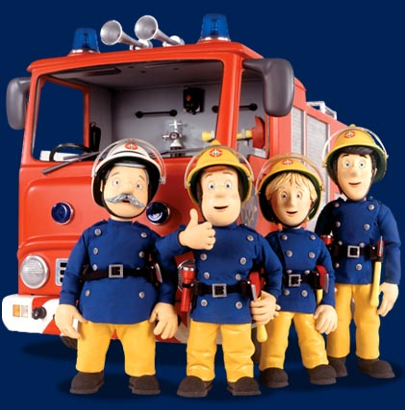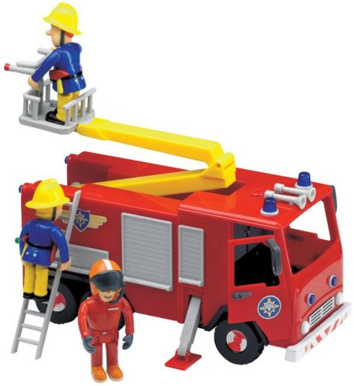Use appropriate language to compare quantities**Physical Development**

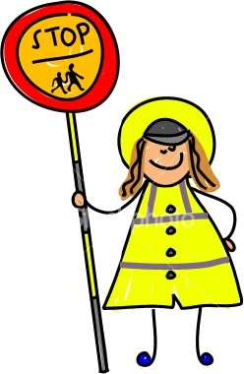Activities will be set up to help children use different tools and materials effectively and safely. As children learn to warm up before physical activities they will learn more about their bodies and as children are encouraged to notice what their bodies can do there are many opportunities for movement and balancing activities. Children in Reception will do P.E in the main hall.

Children will be able to:

* Move with confidence and safety
* Show awareness of space, of themselves and of others
* Use a range of small and large equipment
* Travel around, under, over and through balancing and climbing equipment

## Understanding the World

During this half term the children will have opportunities to make observations to ask questions and compare. Activities such as making pelican crossing lights will help children to gain a greater understanding of how things work in the world around them. Children will develop an understanding of technology through different resources.

Children will learn to:

* Investigate objects and materials by using all of their sense as appropriate
* Find out about and identify some features of, living things, objects and events they observe
* Build and construct with a wide range of objects, selecting appropriate resources
* Find out about past and present events in their own lives and in those of their families and other people they know
* Observe, find out about and identify features in the place they live and the natural world
* Begin to know about their environment and talk about those features they like and dislike

**Expressive Arts and Design**

During this topic children will have lots of opportunities to work with a range of materials and tools. They will make puppets and models. Children will develop their skills of painting and colour mixing as they paint portraits and other pictures. There are a number of songs that children can learn which involve People Who Help Us which can have actions and percussion to allow children to use their imaginations in music. Throughout all the activities children are encouraged to talk about what they see and feel, as they communicate their ideas in painting, music, collage work and role play.

Children will learn to:

* Capture experiences ad responses with music, dance, paint and other materials or words
* [](http://www.google.co.uk/imgres?q=clipart+policeman&safe=active&hl=en&biw=1024&bih=540&tbm=isch&tbnid=i3ICYx_-E7uEVM:&imgrefurl=http://all-free-download.com/free-vector/vector-clip-art/lego_town_policeman_clip_art_25006.html&docid=Rzg7G7PMKLPmXM&imgurl=http://images.all-free-download.com/images/graphiclarge/lego_town_policeman_clip_art_25006.jpg&w=232&h=425&ei=IAHgUeaODMKThgfvqYCwBQ&zoom=1&iact=hc&vpx=272&vpy=100&dur=453&hovh=304&hovw=166&tx=76&ty=189&page=1&tbnh=144&tbnw=78&start=0&ndsp=23&ved=1t:429,r:18,s:0,i:136)Begin to construct, stacking blocks vertically and horizontally making enclosures and creating spaces
* Explore what happens when they mix colours
* Begin to build a repertoire of songs
* Explore the different sounds of instruments
* Engage in imaginative play and role-play based on their own first hand experiences

###### ADDITIONAL INFORMATION FOR PARENTS

**Partnerships with Parents is an area of high importance for our Early Years setting. Please use TAPESTRY as much as possible to celebrate your child’s achievements or share their news.**

**We aim to hold a workshop in the Autumn Term about ‘Phonics and Getting Ready Write’ and it would be great if you could let us know any other areas which you would find useful.**

**P.E. Kit (for children in Reception only):**

Please ensure that your child has a **named PE kit** in school every day. This should consist of:

* a plain white t-shirt
* blue shorts

**Visits/Visitors**

We would like to organise visits into school from different people who ‘help others’ as part of their job. If you are a nurse, doctor, fireman etc. and you would be willing to come in and talk to the children about your job then please let us know.

**Holidays**

During the first week it would be nice to share the children’s holiday experiences. Whether it was a visit to the park, pool or somewhere hot and sunny it would be nice to see a photograph or artefacts to show your child enjoying the break from school.

**Show and Tell**

Children are encouraged to bring in items from home to Show and Tell to the class. It has a positive effect on children’s confidence and also helps their speaking and listening skills. We try to limit the items brought in to topic-related items only but if you have been on a special holiday or it has been your child’s birthday and they would like to share something then please bring it in.

#### Ways you can help your child

**Talking**

Chat in a positive way about local events, and people who help us.

Tell your children about things you notice in the local environment and encourage them to recognise potential dangers in the home/school and on the road.

**Out and about**

[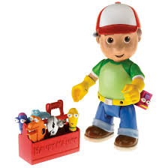](http://www.google.co.uk/imgres?q=handy+manny&safe=active&hl=en&biw=1024&bih=540&tbm=isch&tbnid=z-dEGMUdJy9ozM:&imgrefurl=http://www.ciraslyrics.com/2011/01/handy-doodle-bop.html&docid=DE93c6saxecUwM&imgurl=http://1.bp.blogspot.com/_dxvhQSFhAMs/TUIYLCyZWWI/AAAAAAAAAHs/N9gAc33-sn8/s320/handy+manny.jpg&w=1292&h=1292&ei=eAHgUafGI8iWhQey14H4DA&zoom=1&iact=hc&vpx=753&vpy=181&dur=500&hovh=224&hovw=224&tx=176&ty=189&page=1&tbnh=139&tbnw=114&start=0&ndsp=20&ved=1t:429,r:12,s:0,i:118)Use opportunities to draw children’s attention to people’s jobs and talk about what they would involve i.e; shop assistant, bus driver

**Stories**

Visit your local library to look for books about People Who Help Us.

Please feel free to drop in to Early Years at any time to speak to a member of staff, we are always available before and after school and will be happy to answer any questions or queries.

We look forward to working with you and your child.