Autumn 2 – 2017
Journeys

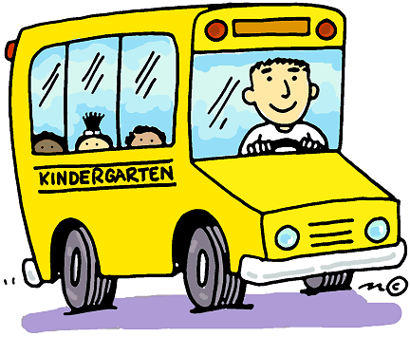

Reception – Mrs Abbott, Miss Thompson and Mrs Haddock
Nursery – Mrs Leja, Miss Kerridge and Mrs Derbyshire

The aim of this leaflet is to give you an overview of the skills
to be covered during the study of this topic. Due to the child
focussed curriculum in the Foundation Stage, we are unable to specify
exactly what we will be doing as it can change regularly depending on the
interests and abilities of the children.

The topic will be used as a vehicle to explore children’s interests within the seven areas of the Early Years Foundation Stage (Personal, social and emotional; Communication and Language; Literacy; Numeracy; Understanding The World; Physical Development; Expressive Art and Design). Within these areas the children will be learning skills and working towards specific goals.

As part of the topic, children will learn about different forms of transport including travel by air, water and road. Towards Christmas we will also cover Santa’s Journey and the Journey to Bethlehem.

Personal, Social and Emotional Development
The topic of Journeys provides valuable opportunities for children to develop awareness of the need to keep themselves and each other safe. Time spent discussing different ways of travelling will encourage children to speak in a group, to share their feelings and to consider the consequences. Children will continue to demonstrate a good understanding of what is right and wrong and be able to share and play fairly with their friends. As the children continue to be familiar with their surroundings, adults and peers they will be confident to try new activities and initiate their own ideas and speak in a familiar group.

Physical Development

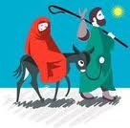
Activities such as playing with balloons, riding sit-and-ride toys around a circuit and following animal trails through the tunnels and over balance beams will offer experience with a range of equipment. The children will use a range of apparatus in P.E and will learn to move around obstacles safely. Several collaborative games offer opportunities to move with control, coordination, imagination and showing awareness of space. Children will continue to work on activities to develop their fine motor skills which include activities in the sand and malleable area, which eventually help their pencil control.

Communication and Language
During this topic all children will be encouraged to take part in various
speaking and listening activities and respond to picture books and stories
using drama. The airport and aeroplane role-play area will allow children to
use their imagination as they plan their journey. Children will make their
own passports and be encouraged to develop their early writing skills by writing tickets and luggage labels. Throughout the topic all children will have the chance to explore the sounds of words and see some of their ideas recorded in both pictures and words. Children will be encouraged to draw maps, mark on directions and be encouraged to tell their own stories about journeys they have been on. As we lead up to the Early Years Nativity performance, the children will be working on their confidence and their ability to speak in a clear loud voice. All children in the Early Years will be involved in this performance and we appreciate your support in helping your child learn the songs, and possibly some lines of script.

Literacy
Phonics
Phonics is taught daily across the school and we follow the Read/Write inc. Program. In Nursery they are distinguishing between different sounds and becoming familiar with sounds around them and in their environment. In Reception, the children are continuing to learn all the single letter sounds in the order according to the Read Write Inc program and simultaneously are learning to form the letters correctly. With practise children are learning to blend sounds to read a word and segment words to write down the sounds they hear. Please encourage your child to write as much as possible, this can include lists, notes and messages around the house. Any marks your child writes are important as this is their way of writing to communicate.

Numeracy
As children carry out the activities in this topic, they will develop mathematical skills in a meaningful context. At the beginning of the topic, children will be asked to contribute to a whole class bar chart, showing how we get to school each day. Sorting and counting skills will help compile and analyse these bar charts. They can also sort different vehicles and count them into sets. Simple activities such as timing journeys around the equipment, introduce the concept of measuring distance and time. There are also opportunities for children to recognise numbers and shapes on road signs and use counting rhymes. Ordering suitcases by size and weight will provide an opportunity for using mathematical language.
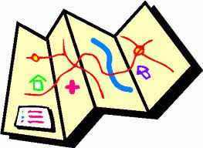

Understanding the World
The topic of journeys provides many opportunities for children
to find out about the place in which they live and the natural
world as well as further afield. Christmas will have a big
emphasis on this topic and when we start thinking about
Santa’s Journey then the children will have several opportunities
to draw maps and make plans for a real journey they want to take or an imaginary adventure which they are going on (perhaps to accompany Santa on his Sleigh!). There are several activities which focus on designing and constructing vehicles using a variety of materials and tools. As they compare the journeys past and present, the children will look at similarities and differences. Throughout all of the activities children will be given the chance to talk about their experiences and to ask questions.

Expressive Arts and Design
During this topic children will experience working with a variety of materials as they make models and use salt dough to create vehicles and shapes. Simple musical activities give opportunities to explore sounds and sing songs and children will learn a number of songs for their Christmas performance. Children will do some printing of different wheels, looking at the size and shape. They will express their ideas through a variety of media including paint, bubbles, collage and musical instruments.

R.E.
Throughout this topic, there will be a strong emphasis on Christmas and all the children will take part in the Nativity Performance. As part of their learning they will understand the Christmas story in detail and be aware of what Christmas means to Christians.

ADDITIONAL INFORMATION FOR PARENTS

All the children have settled very well into their new class and work wonderfully together in the unit. They enjoyed the topic People Who Help Us where they have had the opportunity to meet people with different jobs and have had a chance to think about what they want to be when they are older!

P.E. Kit:
If your child is in Reception, please ensure that they have a named PE kit in school every day. This should consist of:
- a plain white t-shirt
- blue shorts

Please feel free to come in to school anytime
if you have any questions.

