Our next topic is ‘Magical Monsters’ which will give the children an excellent
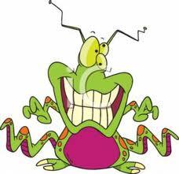
opportunity to explore creatively and imaginatively and make up their own
characters and stories.

The aim of this leaflet is to give you an overview of the skills
to be covered during the study of this topic. Due to the child focussed
curriculum in the Foundation Stage, we are unable to specify exactly
what we will be doing as it can change regularly depending on the interests
and abilities of the children. We have enclosed an enhancement plan to roughly show what we intend to cover each week.

During the topic the children will learn to describe a variety of ‘magical monsters’ using a range of vocabulary. They will make models and puppets to bring their character to life. We will imagine the world ‘they’ live in and compare it to our world, giving children a sense of the world we live in. This topic will be a good vehicle for children to show their own interest and develop their own ideas allowing them to take ownership of their learning. The seven areas of the Early Years Foundation Stage will continue to be explored and learning intentions will be set clearly for the indoor and outdoor environment. Within these areas the children will be learning skills and working towards specific goals. The goals which they will be working towards achieving by the end of the Foundation stage include:

Personal, social and emotional development
Children will continue to develop their understanding of what is right and wrong and be encouraged to build good relationships with their peers and the adults that work with them, we hope children will begin to resolve conflicts independently and work together throughout the unit. Our ‘magical monsters’ topic will also enable children to become more aware of feelings and encourage them to attribute feelings and emotions to made up characters, giving explanations and drawing on personal experiences as to why or what has made them feel that way.
Children will learn to;
- Be aware of feelings, and know that some actions and words can hurt others’ feelings
- Play in a group, extending and elaborating play ideas, e.g. building up a role play activity with other children.
- Take steps to resolve conflicts with other children e.g. finding a compromise.
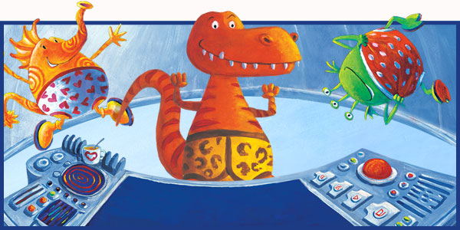
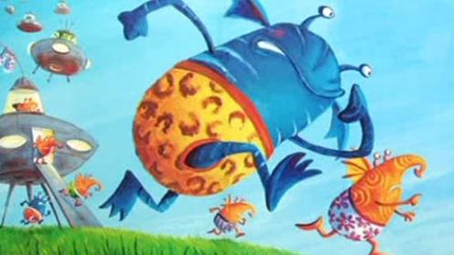
- Begin to accept the needs of others and can take turns and share resources, sometimes with support from others.

Communication and language
There is a vast range of stories which involve ‘monster’ or ‘magical’ characters and we will be reading a selection of theses for the children to have experience of these characters and build up some vocabulary. Children will then be encouraged to make up there own imaginary character that they can describe and develop as far as they want, taking into account descriptive language, different noises and sounds and through answering questions such as who, what where, why and when.
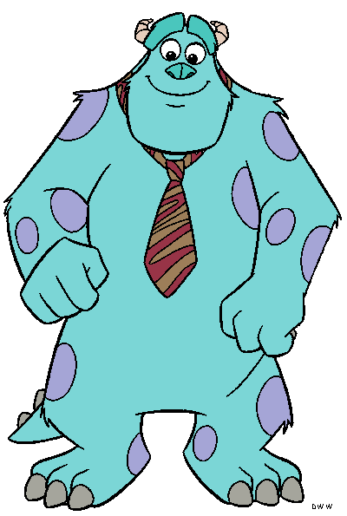
Throughout the topic children will;
- Listen to stories with increasing attention ad recall.
- Join in with repeated refrains and anticipates key events and phrases in rhymes and stories.
- Understand who, what, where in simple questions i.e. who’s that? What’s that? Where is?
- Begin to understand why and how questions.
- Use vocabulary focussed on objects and people that are of particular importance to them.
- Build up vocabulary that reflects the breadth of their experiences.
- Begin to use more complex sentences to link thoughts (i.e. using and, because)

Physical development
We will continue to develop children’s fine and gross motor skills through activities such as threading and weaving, play dough, and small construction. Children will demonstrate a range of fine motor skills through the creation of their own monster using a range of resources such as coloured pencils and pens, scissors and paint brushes. We will also use the topic to set up a monster assault course and play a range of team games. During physical development sessions children will learn to be more independent in their self help skills – dressing and undressing independently as well as beginning to understand a range of healthy practices.
Children will learn to;
- Experiment with different ways of moving
- Travel with confidence and skill, around, under, over and through balancing and climbing equipment.
- Use one handed tools and equipment, e.g. makes snips in paper with child scissors.
- Handle tools, objects, construction and malleable materials safely and with increasing control.
- Dress with help, e.g. puts arms into open-fronted coat or shirt when held up, pulls up own trousers, and pulls up zipper once it is fastened at the bottom.
- Observe the effects of activity on their body.

Literacy
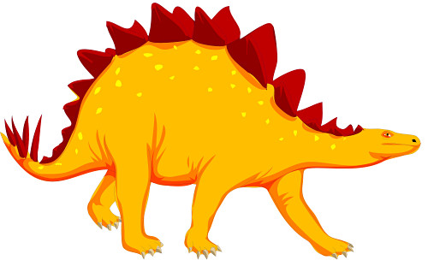
After enjoying a range of topic related books children will describe the main elements of the story in a sequence. During this topic children will also become familiar with poems and will practice recognising and generating rhyme. The will continue to write and mark make for different purposes and will learn about punctuation when forming their own sentence.
Throughout the topic children will learn to;
- Enjoy rhyming and rhythmic activities.
- Suggest how the story might end.
- Describe main story settings, events and principle characters.
- Continue a rhyming string.
- Segment the sounds in simple words and blend them together and knows which letters represent some of them.
- Enjoy an increasing range of books.
- Sometime gives meaning to marks as they draw and paint.
- Use some clearly identifiable letters to communicate meaning, representing some sounds correctly and in sequence.

Mathematics
We will be using the broad theme of ‘Magical Monster’ to encourage the children to use their mathematical knowledge to solve practical problems both indoors and outside. We will continue to count objects and recognise numbers as labels. There will be a focus on writing numbers and recognising numbers to 20. When children are making monsters we will be looking for those who can name the 2D or 3D shapes they are using or can see. There are opportunities for children to count in 2’s, 5’s and 10’s and find the number that is one more or one less than a given number.
Children will learn to;
- Knows that numbers identify how many objects are in a set.
- Shows an interest in number problems.
- Separates a group of three or four objects in different ways, beginning to recognise that the total is still the same.
- Selects the correct numeral to represent 1-5, then 1-10 objects.
- Finds one more or one less from a group of up to five objects, then ten objects.
- Use shapes appropriately for tasks.
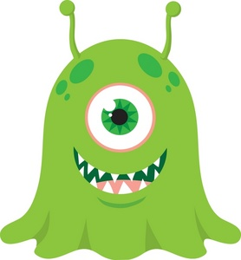
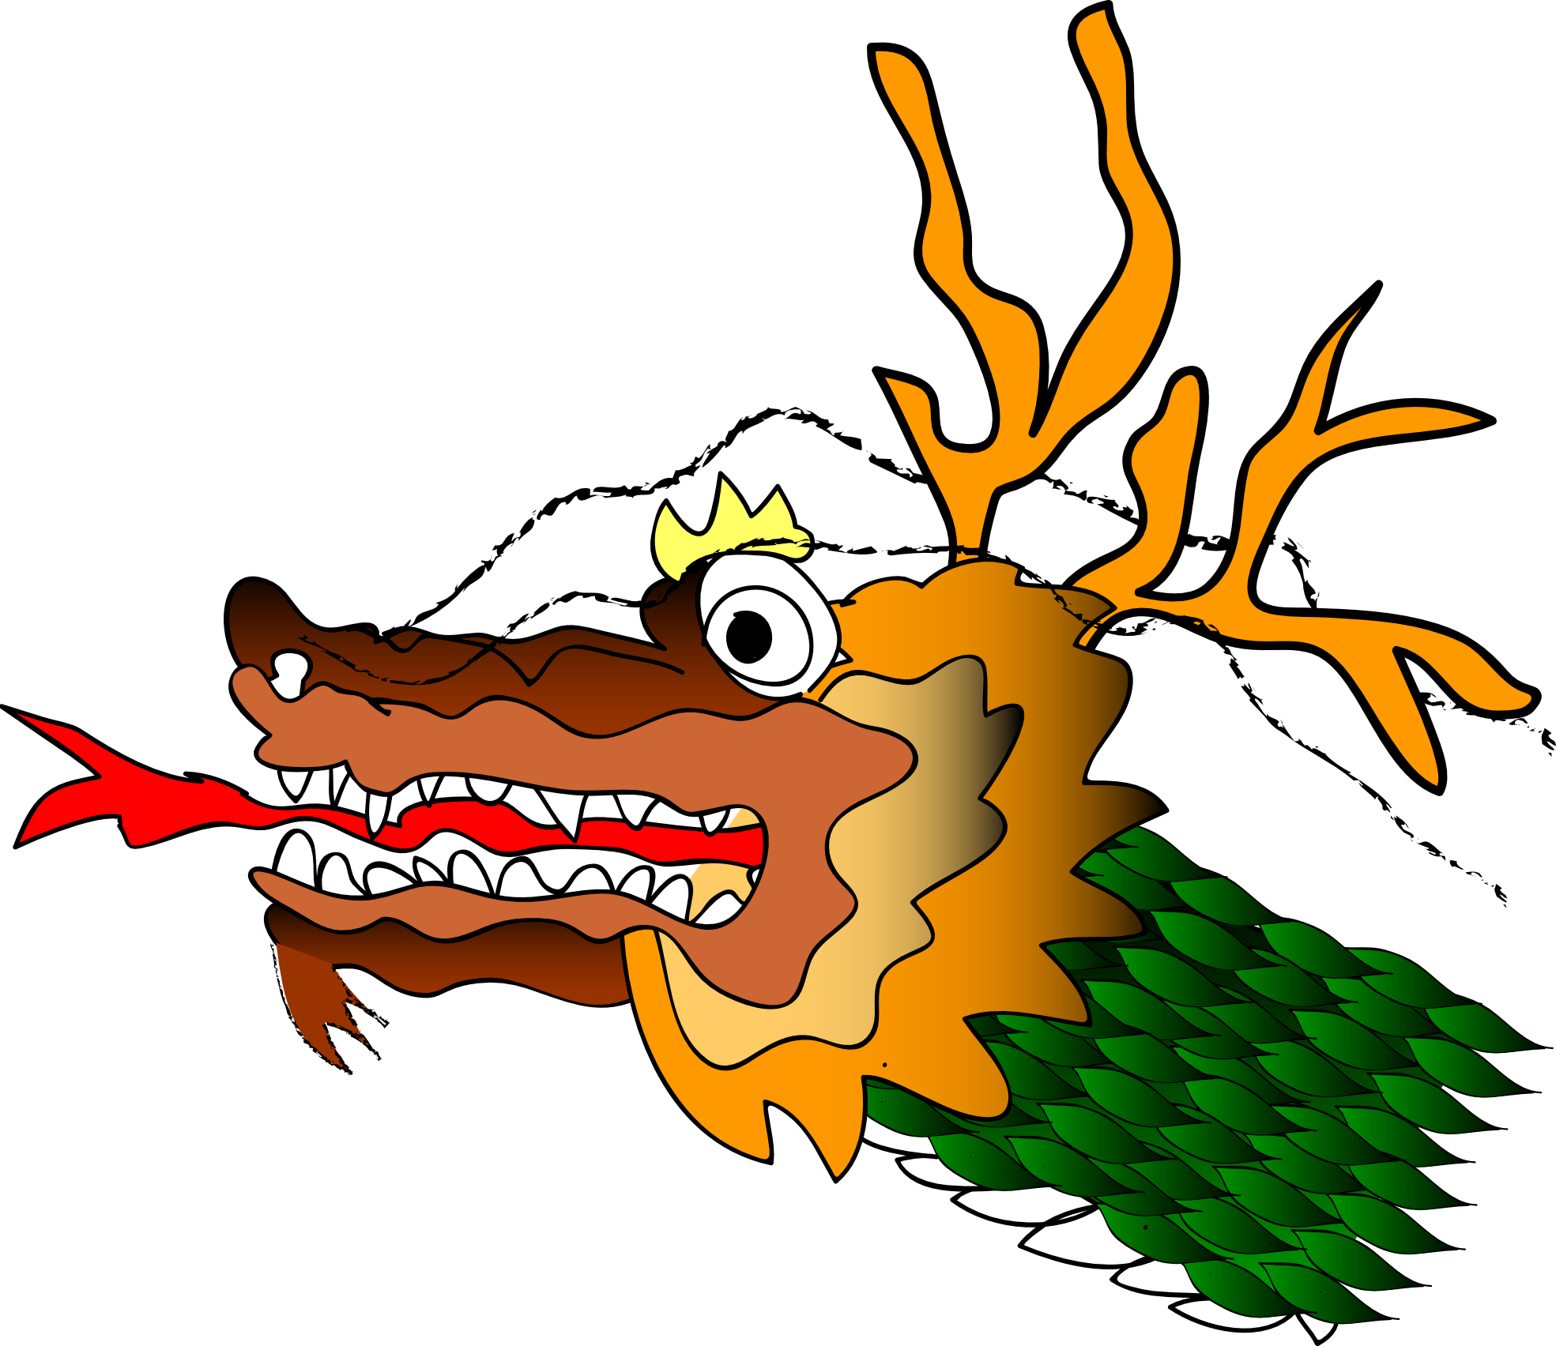
- Beginning to use mathematical names for ‘solid’ 3D shapes and ‘flat’ 2D shapes, and mathematical terms to describe shapes.
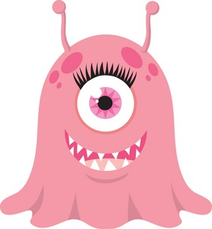
Understanding the world.
After returning to school after the holidays we will begin by encouraging children to talk about their time at home during Christmas. Learning journals will be used as a tool to help us to find out about children’s personal experiences with their families. During our magical monsters topic children will create imaginary worlds and start to discuss the worlds that characters live in, this will lead us into talking about the world in which we live and what features and amenities we have in our local village. We will also develop the children’s understanding of maps and plans by children drawing their own. Through making recycled models children will learn to attach materials in the best way as well as gain an understanding of the importance of recycling and sustainable development.
Children will learn to;
- Remembers and talks about significant events in their own experience.
- Comments and asks questions about aspects of their familiar world such as the place where they live or the natural world.
- Can talk about some of the things they have observed such as plants, animals and natural found objects.
- Shows care and concern for living things and the environment.

Creative development
Through this topic children will be encouraged to create and use their imagination. We will make monster music, monster models and probably a monster mess!! Children will learn some monster theme songs and also learn how music can be created both with our bodies and instruments. Children will have the opportunity to make their own instrument. We will also use a range of materials and techniques to give children different sensory experiences.
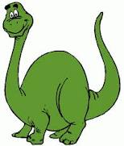
Children will learn to;
- Sing a few familiar songs.
- Explore and learn how sounds can be changed.
- Explore colours and how colours can be changed.
- Use various construction materials.
- Explore the different sounds of instruments.
- Construct with a purpose in mind, using a variety of resources.
- Engage in imaginative role play based on own first-hand experiences.
- Introduce a storyline or narrative into their play.

ADDITIONAL INFORMATION FOR PARENTS
Library: Children in Early Years are taken to the school library on Friday
Mornings. Please ensure your child has their book to bring back and exchange each week. There are still some outstanding books so please have a hunt at home.

P.E. Kit:
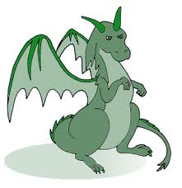
For children in Reception, please ensure that your child has a named PE kit in school every day. This should consist of:
- a plain white t-shirt
- blue shorts
- plimsolls that fit

Visits/Visitors
As yet there are no visitors or visits planned, however this may change according to the children’s interest and the direction the topic takes.

Show and Tell
Please continue to encourage your child to bring in items of interest from home. These should not include toys but an object they can talk and inform others about.

The PARENTAL WORKSHOP this term is focussing on Mathematics – date to be confirmed in the New Year. We had such a great response last term and the comments were fantastic. We look forward to seeing you in the New Year.

Heddon St Andrew’s CofE
First School

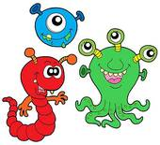

Spring 1 - 2015
Nursery – Mrs Leja and Mrs McGurk
Reception – Mrs Southern, Mrs Abbott and Mrs Haddock

