**This half term in Year 2 we will be learning... l**

**Art and DT**

The children will look at portraits of monarchs and explore a range of art techniques such as pencil, paint, textiles and sculpture to create own portraits.

**Literacy**

Children will be taught Literacy on a daily basis with an hour lesson each day. All children will be taught in topic related literacy lessons focusing on fiction writing exploring story structure, sentence openers and connectives, adjectives and similes in order to develop their writing style.

**Numeracy**

Children will continue to develop their skills in partitioning and recombining and apply this to addition and subtraction calculation. They will also practice multiplication tables and related division facts. They will be solving real life problems involving counting, adding, subtracting, doubling, halving, multiplication and division. We will learn about the fractions of numbers and shape.

**Kings, Queens & happy ever after!**

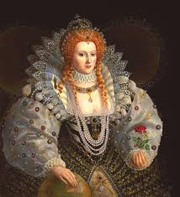 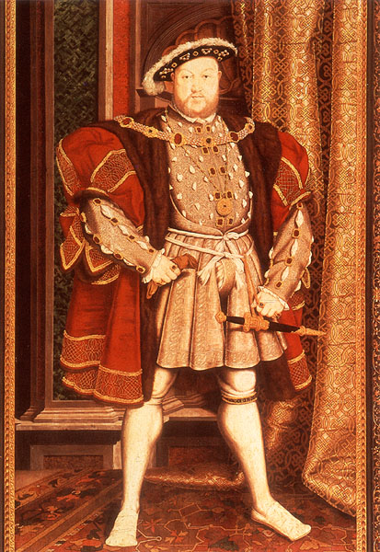 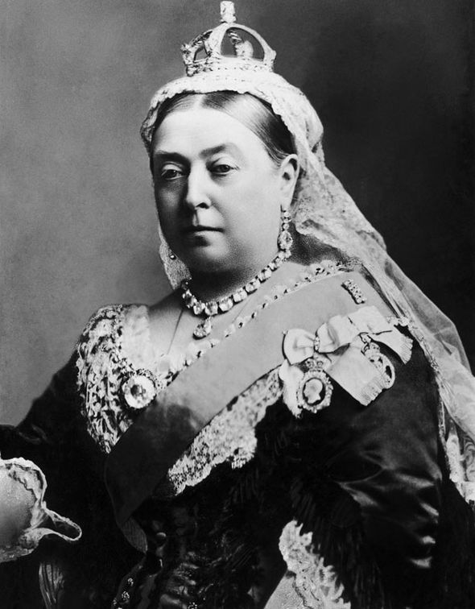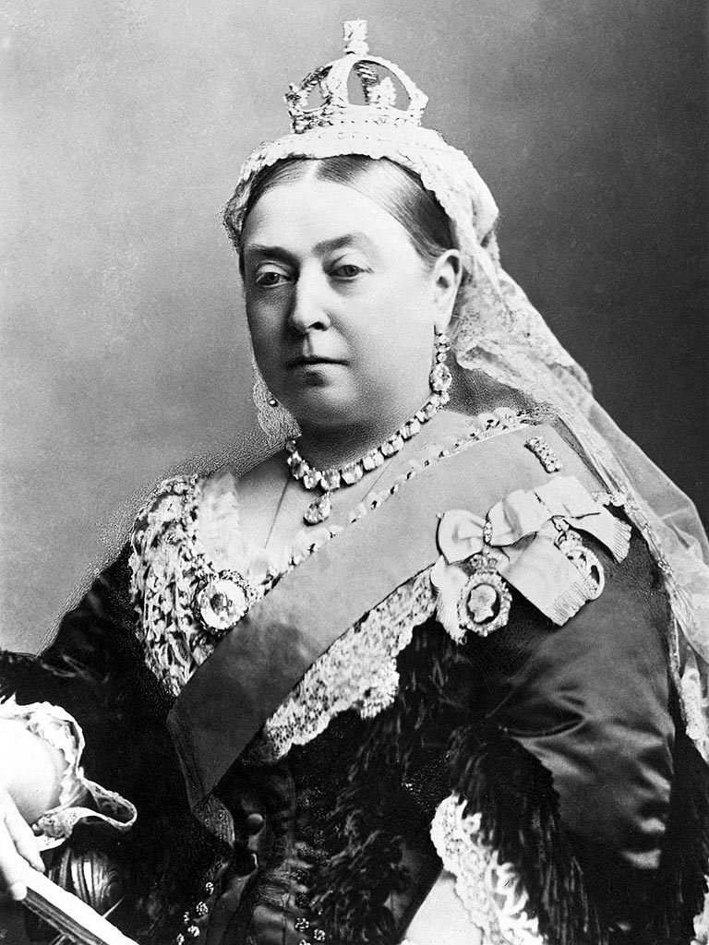

**ICT**

The children will continue developing their skills in gathering information from a variety of sources as well as editing, saving and retrieving information.

**Science**

The children will continue to observe seasonal changes including changes to the weather, temperature and the length of the day.

**Music**

Children will have the opportunity to listen to and respond to music from different eras. They will also create musical patterns and explore, choose and organise musical ideas.

**P.E**

The children will continue to work with our sports partnership teacher developing their dance skills. Children will take part in 2 P.E lessons each week.

**R.E & PSHCE**

In RE the children will learn about Jesus as a friend and about some of the miracles he performed.

In PSHCE the children will learn about belonging to different groups.

**History**

In History children will learn about the history of the British Monarchy, in particular, different Kings and Queens that have ruled. They will learn about how life during specific reigns differs to our lives today.

**S** 