## After half term our topic is ‘Animals’ where we will be learning about

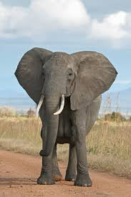different Animals from around the world. The aim of this leaflet is

to give you an overview of the skills to be covered during the study

of this topic. Due to the child focussed curriculum in the Foundation

Stage, we are unable to specify exactly what we will be doing as it can

change regularly depending on the interests and abilities of the children.

During the topic the children will learn about animals living in different

Habitats as well as learning about animals as wild animals and pets.

The seven areas of the Early Years Foundation Stage will continue to

be explored and children will have lots of opportunities to initiate their

own learning. Within these areas the children will be learning skills and

working towards specific goals.

###### Personal, Social and Emotional Development

Children will think about feelings through different animals. Discussions will be about how the animals feel and what makes them scared or happy. We will talk about where different animals live and who they live with. They will also learn how to behave near animals and how to care for pets. Through circle games the children will learn to take turns, to understand the need for agreed codes of behaviour as well as starting to negotiate and solve problems.

**Communication and Language**

Children will listen and share a wide range of quality fiction and non-fiction books which feature animals allowing the children to extend their vocabulary. The children will be able to listen to ideas expressed by others in conversation and respond to what they hear with relevant comments and questions. There will be lots of role-play opportunities for children to use their imagination as they see the sights in the jungle or visit a pet shop.

Physical Development

Activities such as playing with malleable materials and construction toys will give children experience of handling different tools and materials safely and with increasing control. Through pretending to be animals in different places and situations, children will have the opportunity to move with co-ordination, confidence and imagination as well as develop their awareness of safety and space. Using a range of small and large equipment the children will build animals homes. There will be an emphasis this term for the children in Reception to ensure that all letters are formed correctly.

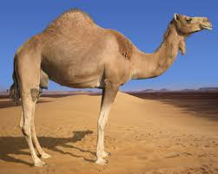[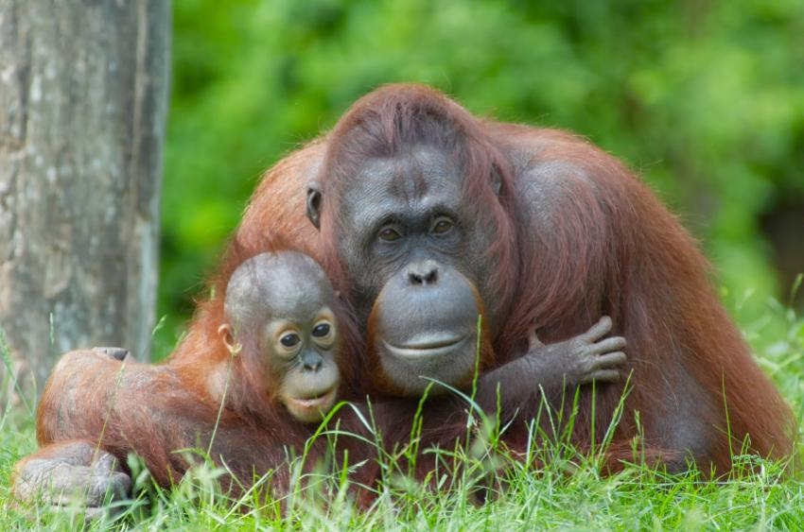](http://www.google.co.uk/url?sa=i&rct=j&q=&esrc=s&frm=1&source=images&cd=&cad=rja&uact=8&ved=0ahUKEwiH16Dy1YPUAhVJ0hoKHe8bDn0QjRwIBw&url=http://home-school.lovetoknow.com/What_Kinds_of_Animals_Live_in_a_Jungle&psig=AFQjCNFEUpFr3wnmPci-i4_sMOLcfYzYlA&ust=1495548324334426)

[](http://www.google.co.uk/url?sa=i&rct=j&q=&esrc=s&frm=1&source=images&cd=&cad=rja&uact=8&ved=0ahUKEwj73ofil4TUAhWjJcAKHdnhC38QjRwIBw&url=http://baddogneedsrottenhome.com/page.html?image%3D1285&psig=AFQjCNEdkU3cAA0NnfK901kkU5rhURtbvw&ust=1495565973961317)**Mathematical Development**

The theme of animals provides a meaningful context

for mathematical activities. Children are given the

opportunity to count a wide variety of animals, legs

and markings and develop language for addition and

subtraction. The children will be able to create their

own mathematical problems based on the topic. There

are opportunities for children to explore size as they

compare animals. A number of counting rhymes with

actions and games that use simple equipment are

suggested to reinforce the theme. The children will be

looking at different animal patterns as well as position.

**Literacy**

During this topic there will be opportunities for children to write and mark-make through different genres; giving children the experiences of creating posters, leaflets, information texts and letters. In Nursery, the children are encouraged to explain the marks that they are making and add interesting detail. The children in Reception will continue to write in full sentences and aim to extend their writing to add more detail and ambitious vocabulary.

[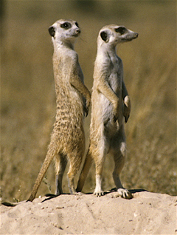](http://www.google.co.uk/url?sa=i&rct=j&q=&esrc=s&frm=1&source=images&cd=&cad=rja&uact=8&ved=0ahUKEwjs-97vmITUAhVhLcAKHZ7xBoUQjRwIBw&url=http://www.fellowearthlings.org/&psig=AFQjCNHBXulEmcXgSQK_uFpO_IGJ_CfFDQ&ust=1495566240708747)

Knowledge and Understanding of the World

During this topic there will be opportunities for children

to make observations, ask questions and compare. They can

observe a range of animal markings, colours and investigate

camouflage. By looking at pictures of wild animals they will

learn about new animals and understand the features that

helps them to be suited to their particular habitats. Children

will be aware that information comes from non-fiction texts

as well as other sources, such as the Internet. Throughout

the topic, children will develop their understanding of living

things.

**Expressive Arts and Design**

###### During this topic, children will experience working with a variety of materials as they make animal collages, print with sponges, weave and finger paint. They will be able to develop their skills of painting and colour mixing as they paint animal patterns and other colourful creatures. Children will learn a number of action songs that involve animals. Throughout all the activities children are encouraged to talk about what they see and feel as they communicate their ideas in painting, music, collage work and role-play.

[](http://www.google.co.uk/url?sa=i&rct=j&q=&esrc=s&frm=1&source=images&cd=&cad=rja&uact=8&ved=0ahUKEwjG5IXim4TUAhVJLMAKHTrlAcgQjRwIBw&url=http://www.freepik.com/free-vector/zebra-print_334788.htm&psig=AFQjCNFfPJQn3Rh9rxpf_BmuXA46xQt9mg&ust=1495567077704982)[](https://www.google.co.uk/url?sa=i&rct=j&q=&esrc=s&frm=1&source=images&cd=&cad=rja&uact=8&ved=0ahUKEwjK-Zi2nYTUAhWhAcAKHbnqBhAQjRwIBw&url=https://www.etsy.com/uk/listing/194968941/animal-print-pattern-leopard-crochet&psig=AFQjCNGdklp9-Ov6Lx7iZfq7sZbbdILvPA&ust=1495567204008055)[](https://www.google.co.uk/url?sa=i&rct=j&q=&esrc=s&frm=1&source=images&cd=&cad=rja&uact=8&ved=0ahUKEwiSuObyn4TUAhWIAcAKHYWxDyQQjRwIBw&url=https://flipboard.com/@shereenmarie/animal-print-q40bon0oz&psig=AFQjCNFE_ek3wovGLatgktLFjjYlEZCisw&ust=1495568165844913)

###### ADDITIONAL INFORMATION FOR PARENTS

**Uniform:**

Please make sure all items of uniform are labelled with your child’s name.



**Library:**

Children in Early Years are taken to the school library

on Friday Mornings. Please ensure your child has their

book to bring back and exchange each week. In Nursery, there is a basket beside the door for you to return your child’s book when they have finished reading it.

**P.E. Kit:**

For children in Reception, please ensure that your child has a named PE kit in school every day. This should consist of:

* a plain white t-shirt
* blue shorts
* a spare jumper/tracksuit bottoms (outdoor P.E.)

**Visits/Visitors:**

As you will see on the enhancement plan we are having a pets week. If you have a pet at home that you would be able to bring in for 20-30 minutes; then please let us know so that we can arrange a time and date. Visitors really enhance the children’s learning and especially if they can get first-hand experience.

[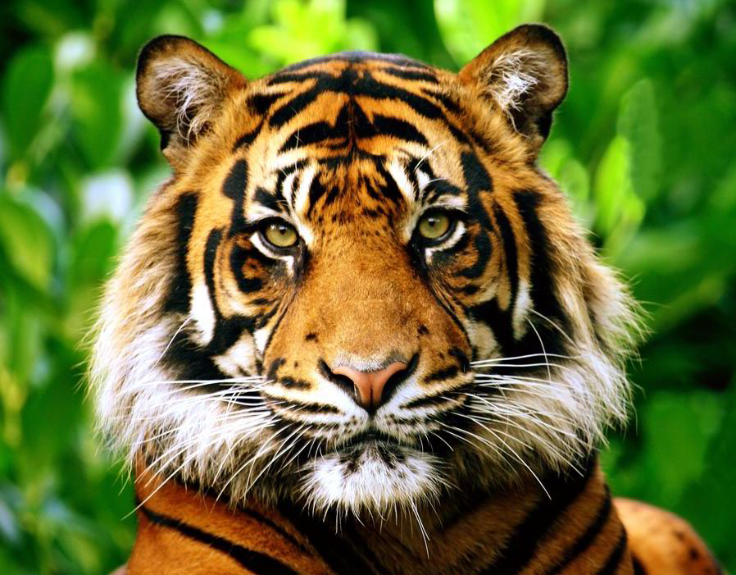](http://www.google.co.uk/url?sa=i&rct=j&q=&esrc=s&frm=1&source=images&cd=&cad=rja&uact=8&ved=0ahUKEwilzKSSm4TUAhWhCsAKHTGRD4QQjRwIBw&url=http://www.express.co.uk/news/nature/733951/WWF-UK-advert-highlights-big-cat-plight&psig=AFQjCNEqmRzcnOX-0ucM3C4aqUbdGZoxKQ&ust=1495566905210344)

We have Zoo Lab coming into school on Tuesday 6th June.

The Ranger will bring a variety of different animals and the

children will be given the opportunity to hold or stroke

the animals if they would like to.

Children in morning Nursery and Reception have a trip to the theatre booked on Friday 30th June to see ‘The Tiger who came to tea’.

**Show and Tell:**

In Nursery, children are encouraged to bring in items of interest from home. These should not include toys but an object they can talk and inform others about.

In Reception, Show and Tell is limited to items of interest related to our topic or relevant to the seasons/time of year.

Heddon St Andrew’s CofE

First School

Animals

[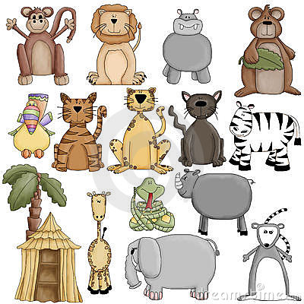](http://www.dreamstime.com/register?jump_to=http://www.dreamstime.com/stock-photos-zoo-animals-clipart-graphics-image10072263)

Summer 2 2017

Nursery – Mrs Leja, Miss Kerridge and Miss Ross

Reception - Mrs Southern, Mrs Abbott,

Mrs McGurk and Mrs Haddock

**Enhancement Plan**

**Summer 2**

|  |  |
| --- | --- |
| **Week** | **Theme** |
| **Week 1**  **WB: 5.6.2017** | **Mini beasts**  Tuesday 6th - Zoo lab visiting school  Friday 9th - Mini beast hunt in the Common  Friday 9th – Reception ‘Fab Friday’ |
| **Week 2**  **WB: 12.6.2017** | **Animals in cold climates** |
| **Week 3**  **WB: 19.6.2017** | **Animals in cold climates**  Friday 23rd – Sports Day   * Early Years 9:15-10:15 * Afternoon Nursery 2:15-2:45 |
| **Week 4**  **WB: 26.6.2017** | **Animals in hot climates**  Friday 30th - Trip to theatre (morning Nursery and Reception children) |
| **Week 5**  **WB: 3.7.2017** | **Animals in hot climates** |
| **Week 6**  **WB: 10.7.2017** | **Pet week**  Friday 14th – Nursery ‘Fab Friday’ |
| **Week 7**  **WB: 17.7.2017** | Monday 17th - Moving up morning and parents drop in session  Thursday 20th - Heddon’s Got Talent!  Friday 21st – Fun morning |