**This half term in Year 2 we will be learning... l**

**Art and DT**

Children will create self portraits using a range of art materials.

Following research of a range of different clocks children will design and make their own clock model. Children will also take part in creating crafts for the Christmas fair.

**Literacy**

Children will be taught Literacy on a daily basis with an hour lesson each day. Some children will continue to follow the Read Write Inc program and others will be taught in topic related literacy lessons focusing on writing skills these will also be taught through other subject areas within the topic.

**Numeracy**

Children will develop their skills in estimating, measuring, weighing and comparing objects using suitable uniform non standard units and measuring instruments. Children will revise reading the time to the hour and half hour. In number work children will be solving problems involving counting, adding, subtracting, doubling and halving. We will continue practicing counting on and back in twos, fives and tens.

**ICT**

The children will continue developing their skills in gathering information from a variety of sources as well as editing, saving and retrieving information.

**Talking Time**

[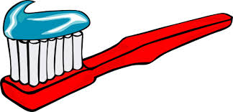](http://www.google.co.uk/imgres?imgurl=http://childrenstorytales.com/wp-content/uploads/2011/09/Toothbrush-and-toothpaste.png&imgrefurl=http://www.childrenstorytales.com/scrub-b-the-toothbrush/&h=289&w=600&tbnid=XpF95h9UBmc7RM:&zoom=1&q=tooth%20brush&docid=0eLL3YtErx0_ZM&hl=en&ei=5HhGVOvEEIjbapmzgPAE&tbm=isch&ved=0CD4QMygVMBU&iact=rc&uact=3&dur=693&page=2&start=14&ndsp=16) [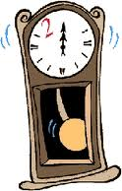](http://www.google.co.uk/imgres?imgurl=http://www.destinationgod.com/images/155_Grandfather_clock.gif&imgrefurl=http://www.destinationgod.com/destinationgod.html&h=243&w=155&tbnid=Yo7IIFducGeMpM:&zoom=1&q=cartoon%20grandfather%20clock&docid=C1QM71cJuBnpqM&hl=en&ei=IHlGVLyAKovZaumpgeAG&tbm=isch&ved=0CC4QMygMMAw&iact=rc&uact=3&dur=439&page=1&start=0&ndsp=23)****[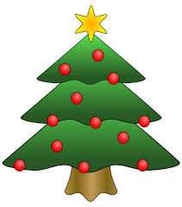](http://www.google.co.uk/url?sa=i&rct=j&q=cartoon%20christmas%20tree&source=images&cd=&cad=rja&uact=8&ved=0CAcQjRw&url=http://www.clker.com/clipart-7176.html&ei=xHlGVIKNKc3qaKT9ggg&bvm=bv.77880786,d.d2s&psig=AFQjCNEiEI5g887OgtHiSzp-A61XWqiFZA&ust=1413991207776169)

[](http://www.google.co.uk/imgres?imgurl=http://www.clker.com/cliparts/d/e/3/f/11949910871041254139christmas_tree_01.svg&imgrefurl=http://www.clker.com/clipart-7176.html&h=602&w=531&tbnid=dogUrQa70SG0vM:&zoom=1&q=cartoon%20christmas%20tree&docid=vSrgwhwy7J6sRM&hl=en&ei=p3lGVJjkEMPTaLmcgcgB&tbm=isch&ved=0CCUQMygGMAY&iact=rc&uact=3&dur=465&page=1&start=0&ndsp=18)[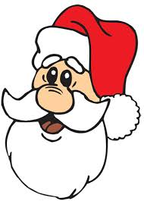](http://www.google.co.uk/imgres?imgurl=http://www.cartoonfactory.com/lessons/images/SantaFace-a.gif&imgrefurl=http://www.cartoonfactory.com/lessons-santa-claus.html&h=522&w=375&tbnid=FZebRbZuOQoAtM:&zoom=1&q=cartoon%20santa&docid=oNTvditqnO_5JM&hl=en&ei=V3lGVKDLH9LrareugMgG&tbm=isch&ved=0CHIQMyhJMEk&iact=rc&uact=3&dur=353&page=4&start=57&ndsp=21)

**Science**

Following on from healthy eating work covered in Food & Farming children will explore the need for exercise and personal hygiene.

**R.E & PSHCE**

In R.E. children will continue to learn about the importance of the Bible as well as learning about special books in non-Christian faiths.

Children will also learn about the gift of Christmas and how the gift of Jesus shows God’s love and care for the world

**Music**

Children will have the opportunity to listen to and respond to music from different eras. They will alsorehearse and perform songs forthe Christmasperformance.

**P.E**

The children will continue to work with our sports partnership teacher developing their gymnastic skills. Children will take part in 2 P.E lessons each week.

**History**

In History children will learn how to place events and objects linked to themselves and their families in chronological order. Children will explore the ‘passing of time’. Identifying and comparing ‘then and now’ events and objects.

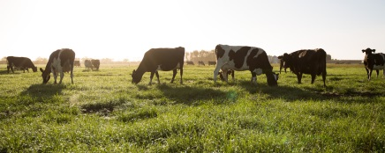

**Additional Information:**

**Reading:**

Please hear your child read every day, either from a school reading book, or a book from home. Please ensure that you record when you have read with your child in their Reading Record Book. There is a ‘reading box’ in the classroom where your child should put their book when they require a new one. Books will be changed on Tuesdays and Fridays if they are put into the box.

**Spellings:**

Big Spell Beat That! Your child will bring home new words to learn. They will be tested every Monday. Please help them to practice their spellings.

**Homework:**

Weekly homework will consist of reading, spelling and Big Maths Challenge practice. Occasionally, other topic or holiday homework may be sent home to consolidate/support work done in school.

**P.E:**

There are two P.E. sessions per week and this half term we will focus on gymnastics. Your child should have their P.E. kit in school each day; this should consist of named shorts, t-shirt and plimsolls or trainers. P.E. will be on Wednesday and Thursday afternoons this half term.

**Water Bottles:**

Please continue to send your child to school each day with a named water bottle. There is a box in the classroom where children can store their bottles. Please ensure they are washed and refreshed daily.

**Visits/visitors:**

As yet there are no planned visits this half term.

Finally, if you have any concerns or questions regarding your child, please do not hesitate to contact us.

Mrs Bilclough and Mrs Cubbage

**Year 2 - Autumn Term 2014**