Northumberland
County Council
HEDDON-ON-THE-WALL ST. ANDREW’S CHURCH OF ENGLAND FIRST SCHOOL

Trajan Walk • Heddon-on-the Wall • Northumberland • NE15 0BJ
Telephone 01661 853350

Mr A Wheatley: Headteacher
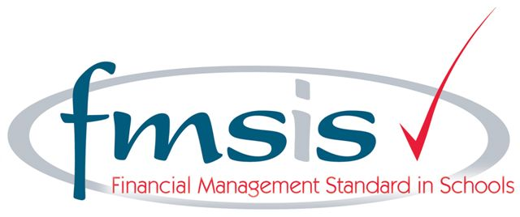

Primary Physical Education and Sport Premium

The Government has provided funding to the school through the Primary Physical Education and Sport Premium.

The Government vision for the Premium is:

A measurable and sustained improvement in school PE and sport, underpinned by high quality teaching that increases participation levels in physical activity, and leads to healthier pupils who are more engaged across the whole curriculum. This will be the legacy to the London 2012 Olympic and Paralympic Games.

The vision is to be achieved through the completion of the following objectives:

1: To improve the quality of existing PE teaching through continuing professional development in PE for generalists, so that all primary pupils improve their health, skills and physical literacy, and have broader exposure to a range of sports.

2: To increase participation levels in competitive sport and healthy activity of pupils, and maintain these into adolescence.

3: To increase the quality of initial teacher training in PE and sport, and to promote PE specialisation in primary level workforce.

4: Schools understand and value the benefits of high quality PE and sport, including its use as a tool for whole school improvement.

The funding allocation of the grant to school was:

Academic Year 2013 / 2014: £6000
Academic Year 2014 / 2015: £6500

Spending of the Sport Premium during Academic Year 2013 / 2014

The school used the Sport Premium to buy in the services of the Morpeth and Ponteland School Sports Partnership

The breakdown of costs were:

Sports Partnership Service Level Agreement: £6000 including cost of transportation to inter-school events and festivals.

Impact of the Sport Premium

During the academic year 2013 / 2014 the Sports Partnership provided:

3 hours per week of high quality PE and sports teaching from a qualified School Sports Co-ordinator. Including set up time and transitions between sessions this was split up into:

- 30 minutes per week for Reception;
- 1 hour per week for Year 1;
- 1 hour per week for Year 2.

The programme of activities changed each half term throughout the year and included a mix of general physical skill development, specific games skills and learning how to play a variety of sports.

The programme was:

- Multi-Skills;
- Dance;
- Gymnastics;
- Racket Skills;
- Ball Skills (with a focus on Tag-Rugby);
- Athletic Skills.

Key Stage 1 also participated in the Multi-Skills and Hoopstarz Festivals with other partnership schools.

Key Stage 2 participated in the following inter-school competitions allowing children to compete against their peers in other schools:

- Gymnastics (1 team)
- Tri-Golf (2 teams)
- Tag Rugby (2 Year 4 teams)
- Tag Rugby (2 Year 3 teams)
- Athletics (5 teams)

Year 3 were all trained as Young Sports Leaders during the Summer Term. They then led activities and supported at our Cricket Festival as well as leading sports and games with younger pupils during play and lunchtimes.

BikeAbility was provided for pupils in Year 4.

Staff report that behaviour during the PE sessions is good with high levels of engagement including those with more challenging behaviour.

Pupils have reported high levels of enjoyment both in response to the expert led lessons and about participation in competitions against other schools.

Levels of participation

Competitive sports: All pupils (100%) in Key Stage 2 had the opportunity to compete in at least one competition against other schools (52 pupils)

Pupils had the opportunity to compete against each other intra-school when practising for the competitions.

Reception and Key Stage 1 pupils competed against each other through games and activities when developing skills and understanding of sports.

Healthy physical activity and skill development: All pupils (100%) in Reception and Key Stage 1 received high quality Physical Education as detailed above (73 pupils)

Extra-Curricular Clubs
The School currently has two after school sports clubs: Karate and Gary Ives Football. Both clubs are privately run and those pupils in receipt of Pupil Premium have the costs met for them.

Participation Levels: Karate: 10
Gary Ives Football: 25

Teacher Training and PE Specialisation

Through the Sports Premium the Sports Partnership provided:

- Opportunities for all staff working in Key Stage 1 and Reception to observe high quality PE delivery taught by the qualified School Sports Co-ordinator;
- Programmes of Study for each half term showing how to attain progression and development of skills;
- Weekly planning for each session allowing staff to reinforce skills learnt by pupils in the second PE lesson each week;
- Access to high quality Professional Development training courses for staff delivered by specialist coaches for all schools in the Partnership.

Sainsbury’s School Games Kitemark

Through work carried out the school applied for the School Games Kitemark which demonstrates a commitment to ensuring high quality Physical Education and developing both competitive sports and healthy activity.

The school achieved the Bronze School Games Kitemark.

Academic Year 2014 / 2015

The school has received Primary Physical Education and Sport Premium funding of £6500 for the academic year 2014 / 2015.

Planned spending of the Sports Premium for 2014 / 2015:

- Morpeth and Ponteland School Sports Partnership which includes:
*4 hours of expert led curriculum PE each week;
*1 After School Club;
*Young Sports Leader Training for Year 3;
- Transport to competitions and festivals;
- BikeAbility for Year 4;

