Northumberland
County Council
HEDDON-ON-THE-WALL ST. ANDREW’S CHURCH OF ENGLAND FIRST SCHOOL

Trajan Walk Heddon-on-the Wall Northumberland NE15 0BJ
Telephone 01661 853350

Mr A Wheatley: Headteacher
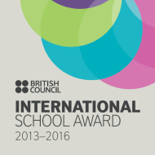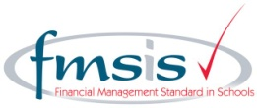

Pupil Premium

What is the Pupil Premium?

The Pupil Premium is a sum of money which is paid to the school to support your child during their time at school.

Children who are on or have been in receipt of Free School Meals within the last 6 years or children whose parents are in the Armed Forces are eligible for the funding.

How the Funding will be used in this School:

The funding can be used to support your child in the following ways:

- Extra-curricular sports activities;
- Music lessons;
- School visits;
- Swimming with School;
- Provision of learning resources and specific learning programmes in school.

If you think that you may be eligible for Free School Meals and therefore able to access the Pupil Premium funding for your child please call into the School Office to discuss this further.

Many thanks,

Mr. A. Wheatley
Headteacher

