Northumberland
County Council
HEDDON-ON-THE-WALL ST. ANDREW’S CHURCH OF ENGLAND FIRST SCHOOL

Trajan Walk • Heddon-on-the Wall • Northumberland • NE15 0BJ
Telephone 01661 853350
www.heddon-school.co.uk twitter @HeddonSchool
Mr A Wheatley: Headteacher
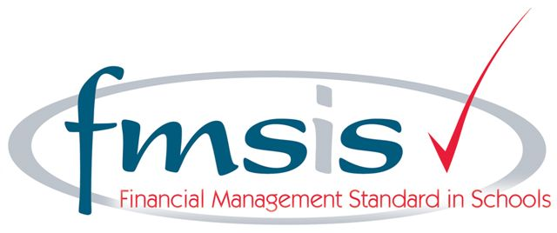

September 2015
Pupil Premium Report 2014 / 2015

Number of pupils in receipt of Pupil Premium 2014 / 2015: 7
Number of pupils in receipt of Forces Premium 2014 / 2015: 1

Number of pupils in receipt of Pupil Premium 2015 / 2016: 5
Number of pupils in receipt of Forces Premium 2015 / 2016: 10

Principles Underpinning our use of Pupil Premium

"The King will reply, 'Truly I tell you, whatever you did for one of
the least of these brothers and sisters of mine, you did for me.”
Matthew 25:40

The Government believes that the Pupil Premium, which is additional to main school funding, is the best way to address the current underlying inequalities between children eligible for free school meals (FSM) and their wealthier peers by ensuring that funding to tackle disadvantage reaches the pupils who need it most.

- Heddon-on-the-Wall St. Andrew’s CE First School strongly believes that all learners are uniquely made in the image of God and therefore we strive to provide the best possible standard of education for all learners, from all backgrounds, cultures and faiths regardless of ability. We are proud of our inclusive ethos and approach which offers a wide range of activities, resources and opportunities for all learners in our care;

- We ensure that teaching and learning activities and opportunities are relevant to and meet the needs of all learners;

- Those learners in vulnerable groups (including those eligible for Pupil and Forces Premium) are identified and appropriate support, both educational and emotional is provided following an accurate assessment of need;

- It is recognised that not all those learners who come from socially disadvantaged backgrounds or other eligible categories such as being adopted, will be in receipt of Free School Meals or Pupil Premium;

- In light of the above point the school reserves the right to allocate Pupil Premium funding to support any learner or groups of learners the school has legitimately identified as being socially disadvantaged;

- Pupil Premium and Forces Funding will be allocated following a needs analysis which will identify priority individuals or groups. The limited Pupil Premium funding received means that not all learners receiving Free School Meals may be in receipt of interventions at one time.

Provision

The Governors have considered the following provision:

- Providing additional trained Teaching Assistant support to improve opportunities for quality marking and feedback therefore increasing efficiency of Assessment for Learning and accelerating progress;
- Providing additional small group work with a trained Teaching Assistant focusing on addressing specific gaps in learning to take place before school begins in the morning and during the school day;
- Providing 1:1 support where required;
- Purchase of specific learning resources and programmes;
- Funding additional training which will be cascaded and enable staff to more effectively support learners with academic, emotional and behavioural issues;
- Funding support for enrichment activities;
- Funding school visits and swimming lessons;
- Funding after school clubs including sports clubs to increase engagement with school;
- Funding of individual peripatetic music lessons within school.

All work related to Pupil Premium is aimed at accelerating progress for learners in Literacy and Numeracy and is to move them to at least the expected level for their age.

The Pupil Premuim Funding for 2014 / 2015 was £15,600 and was targeted for:

- Provision of before school group focusing on Reading and Numeracy;
- Learning Support in class / small groups / 1:1;
- Assistance with swimming costs;
- Assistance with school trip costs;
- Assistance with After School Club costs;
- Assistance with peripatetic music lessons;
- Learning Resources.

Impact of Pupil Premium and Forces Premium Funding

Year 1 Phonic Screen

 | % Achieving Pass Mark | Average Score (Out of 40)
Pupil / Forces Premium | 100% | 36
Whole Cohort | 82% | 32

Performance in the Phonic Screen was high and exceeded that of the cohort as a whole both in terms of average score and % achieving the pass mark.

End of Key Stage 1 Results

Performance at the end of Key Stage 1 was high exceeding the National Expectation and National Averages (2014) for all children in all areas.

Progress across Year 2 and Key Stage 1 was high exceeding expected levels of progress in all measures.

Average progress across Year 2 is 3 points. Pupil / Forces Premium learners achieved 6.7 points in ‘All Subjects’.

Average progress across Key Stage 1 (Year 1 and 2) is 6 points. Pupil / Forces Premium learners achieved 10 points in ‘All Subjects’.

 | Reading | Writing | Numeracy | All Subjects
Start of Year 2 | 11 | 11 | 11 | 11
End of Year 2 | 18 | 17 | 18 | 17.7
Progress Made | 7 | 6 | 7 | 6.7

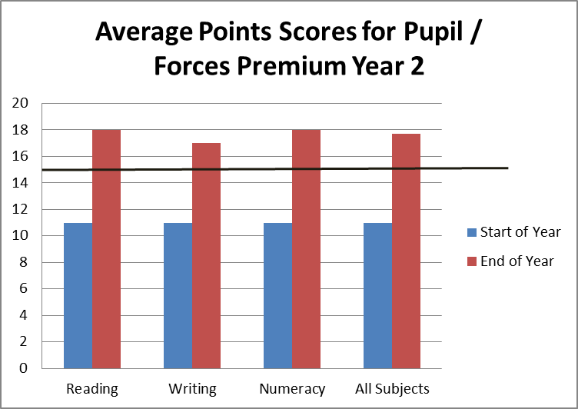
National Expectation end of Year 2

 | Reading | Writing | Numeracy | All Subjects
Start of Year 1 | 7 | 8 | 8 | 7.7
End of Year 2 | 18 | 17 | 18 | 17.7
Progress Made | 11 | 9 | 10 | 10

100% of Pupil / Forces Premium learners reached the expected level or better for their chronological age in all areas.

Achievement across the School

Taking data from Key Stage 1 and 2 shows good progress across the year with all measures showing an increase in the % of learners achieving the National Expectations or better for their chronological age as set out in the National Curriculum (2014).

The following graphs show the % proportions of learners at each step compared to the National Expectations for their age at the beginning and end of the academic year 2014 / 2015.
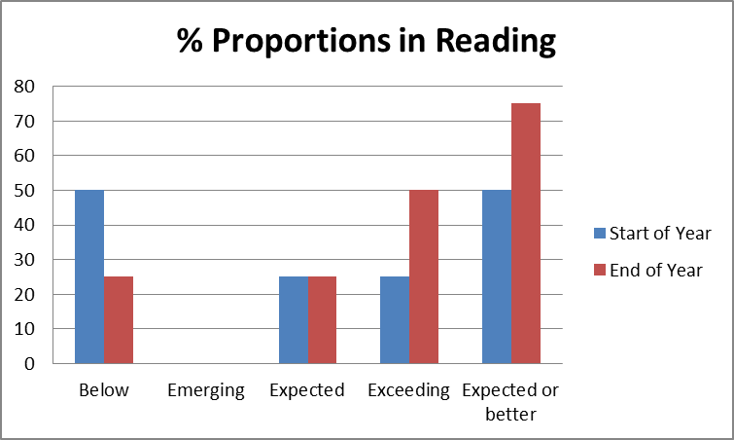

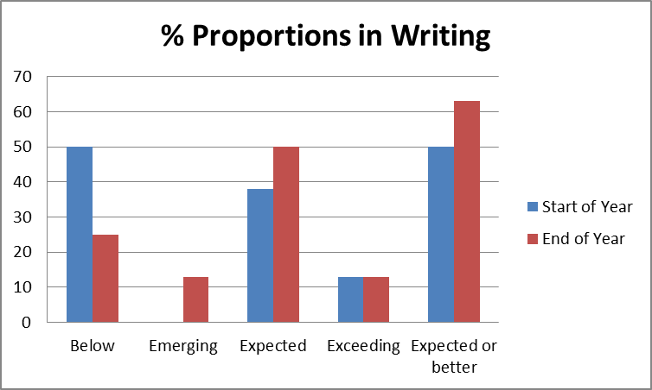

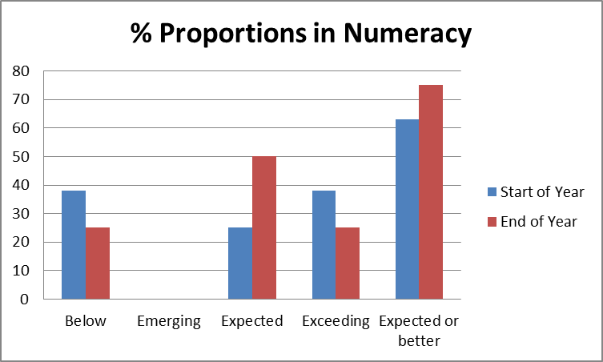

All learners entitled to Pupil / Forces premium accessed their funding at some point during the academic year 2014 / 2015.
As well as the academic attainment and progress detailed above, feedback from parents and carers also highlighted the difference some interventions, particularly the before school group, made to their children. They felt that this specific intervention made their children feel special and increased their engagement with not only school but learning in general. It was also felt by parents that it had postively impacted on the confidence of their children in trying new things and increased their resilience in learning.

By the end of the academic year 2014 / 2015 all Pupil / Forces Premium learners could swim the National Expectation for the end of Key Stage 2 (Year 6) of 25 metres. Of the learners involved in swimming only one could swim prior to attending lessons through school. Therefore 80% of the learners involved progressed from either being non or weak swimmers to being able to swim.

Pupil / Forces Premium funding for 2015 / 2016 is: £9,750 and will be targeted for:

- Continued provision of before school group focusing on Reading and Numeracy;
- Learning Support in class / small groups / 1:1 including delivery of individualised programmes such as SYDNEY;
- Purchase of Pupil Attitudes to Self and School (PASS) online survey tool to help identify hidden barriers to learning and progress;
- Assistance with swimming costs;
- Assistance with school trip costs;
- Assistance with After School Club costs;
- Assistance with peripatetic music lessons;
- Learning Resources including:
*additional iPads to allow Forces learners to communicate with parents who are on active service;
*Games and activities to support development of emotional literacy, friendship and resilience;
- Training for staff and materials for Early Talkboost to support and enhance the early speech and talk development of learners in school.

