**This half term in Year 1 we will be learning...**

**Literacy**

Children will be taught Literacy on a daily basis with an hour lesson each day. Some children will continue to follow the Read Write Inc program and others will be taught in topic related literacy lessons. Writing skills will also be taught through other subject areas within the topic.

**Food and Farming**

[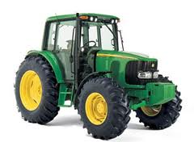](http://www.google.co.uk/url?sa=i&rct=j&q=tractor&source=images&cd=&cad=rja&uact=8&docid=LzBZY_1U4zlpPM&tbnid=xqM8IouEkybjIM:&ved=0CAUQjRw&url=/url?sa=i&rct=j&q=tractor&source=images&cd=&docid=LzBZY_1U4zlpPM&tbnid=xqM8IouEkybjIM:&ved=&url=http%3A%2F%2Fwww.holtontractors.co.uk%2F&ei=Yz61U6uRE86_PMn-gIAK&bvm=bv.70138588,d.ZWU&psig=AFQjCNHMiNUB3t3XjPK3PxsawsQoYT6TGw&ust=1404473315566836&ei=dT61U9bzNsLS0QWh4IHYCw&bvm=bv.70138588,d.ZWU&psig=AFQjCNHMiNUB3t3XjPK3PxsawsQoYT6TGw&ust=1404473315566836)

**Numeracy**

Children will continue developing their skills in number, counting, partitioning and calculating as well as using practical and developing mental strategies for addition, subtraction, multiplication and division. They will also begin to explore money, data handling, measures, shape and number patterns and problem solving.

**Art and DT**

In Art children will explore the design attributes of different food packaging before designing and making their own packet.

The children will use a range of joining techniques in DT to create a moving farm vehicle/machine.

**Science**

During this topic children will be learning about living things and their habitats, animals including humans and plants. We will also be looking at where food comes from, how animals are cared for and about healthy diet and exercise.

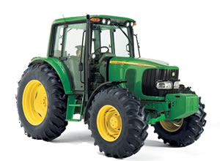[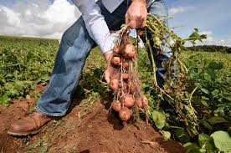](http://www.google.co.uk/url?sa=i&rct=j&q=crop+farming&source=images&cd=&cad=rja&uact=8&docid=yG7brAZgYUd15M&tbnid=nkccW0EjLNTu6M:&ved=0CAUQjRw&url=http://tcktcktck.org/2013/01/potatoes-with-person-in-crop-field-photo/40527&ei=fUi1U-LhGcnM0QXJv4GICg&bvm=bv.70138588,d.ZWU&psig=AFQjCNFkbXVS9ryxjTmpR_n1wrNGKX2RNA&ust=1404475876603414)

**ICT**

The children will be taught to gather information from a variety of sources and to enter, store and retrieve information. They will use text, tables and images in their work.

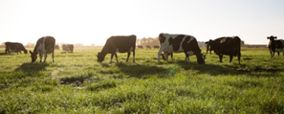

**Music**

In music children will be taught to use their voices expressively when singing songs, chants and rhymes. They will also explore a range of musical instruments and patterns. They will compose, rehearse and perform songs and music.

**R.E & PSHCE**

In R.E. we will be learning about the bible and why it is so important to Christians. We will look more closely at the Old and New Testament and read important stories from the bible. In PSHCE we will be exploring relationships between people and preparing to play an active role as citizens.

**P.E**

The children will continue to work with a sports partnership teacher developing their dance skills. They will also learn

